**My Animal’s Big Problem**

**Step 1: Spot the Problem!**

Look at the pictures below. Circle the one that shows a problem for our environment.

***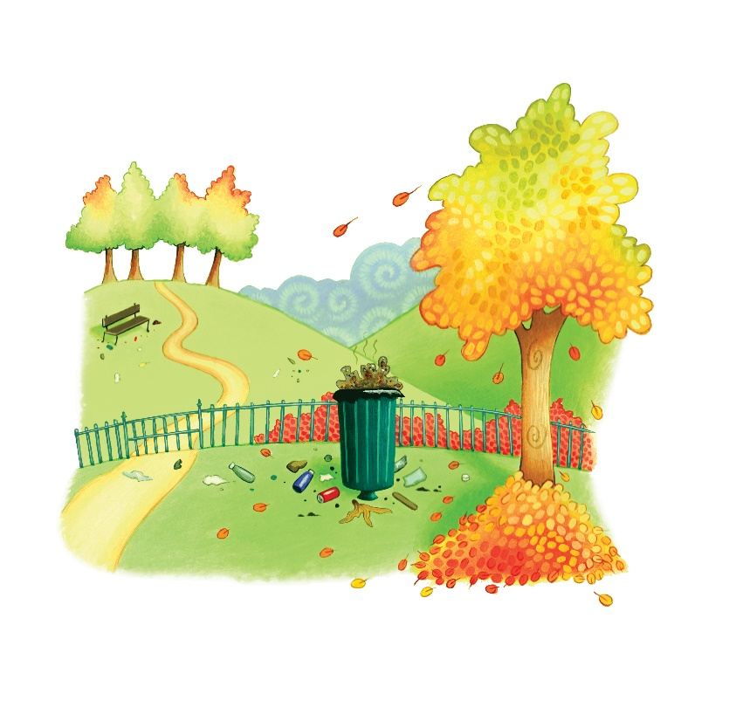*What is the problem?**

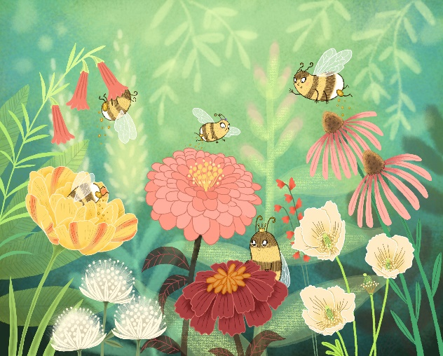

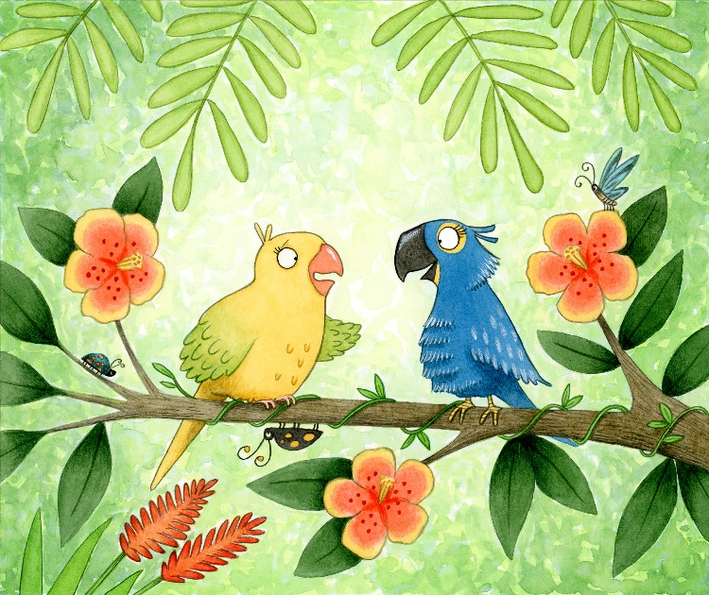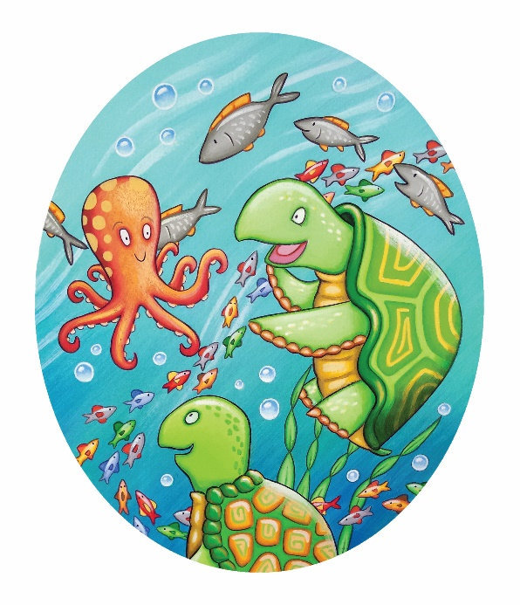

**Step 2: Where does your animal live?** Circle one or write your own:

* forest
* jungle
* ocean
* park
* beach
* pond
* ice cap
* cave

My animal lives in / on a(n): _______________________

**Step 3: What is the problem?** Help your animal! What is going wrong in the place where they live? Use these words to help:

* rubbish/trash
* no food
* dirty water
* trees are being cut down
* animals are scared

The problem is: _______________________________________________________

**Step 4: How can we fix it?** Think of a smart and kind idea to help your animal!

Use these words to help:

* pick up
* clean
* plant
* recycle
* build
* protect

The solution is to: _______________________________________________________

**Check Your Writing!**

[ ] Capital letters at the beginning of my sentences.  
[ ] Full stops at the end.  
[ ] I used finger spaces.