**Character Creator!**

**Step 1: Who is your animal character?** (Circle one or draw your own!)

A prickly hedgehog  
A playful penguin  
A muddy elephant  
A buzzy bee

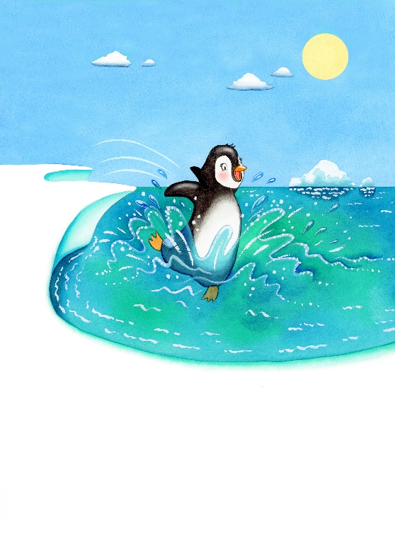

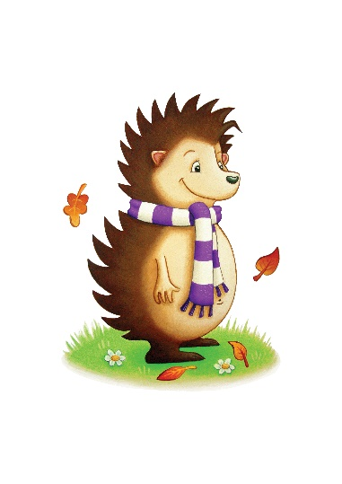

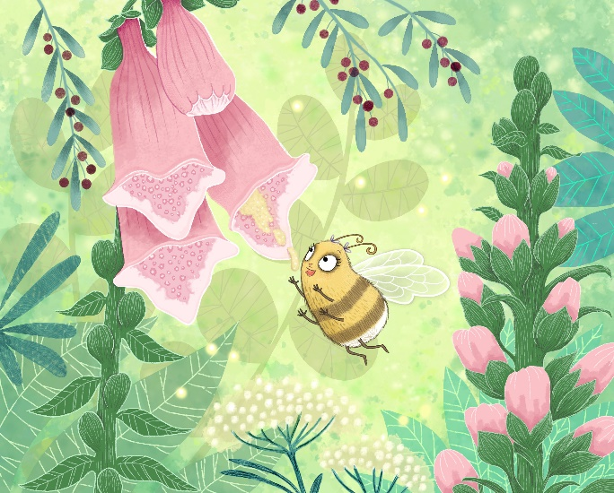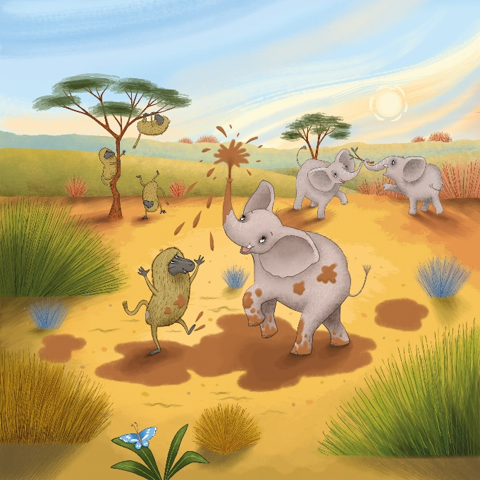

**Step 2: What does your animal character look like? Describe your animal.** Pick 2–3 real describing words: [Mini Word Bank – Real Adjectives]

* furry
* scaly
* big
* tiny
* scary
* smooth
* stripey
* spotted
* prickly
* muddy

My animal is: ___________________________________________

**Step 3: What is the personality of your animal character like?** (Choose words from the word bank!)

**Word Bank:**  
Brave | Funny | Kind | Sneaky | Silly | Clever | Gentle | Thoughtful | Sensible | Playful | Adventurous

My character is _________________________ and _________________________.

**Step 4: Add Rhyming Adjectives! (Make them up!)** [Mini Word Bank – Rhyming Ideas]

* wishy-washy
* snappy-happy
* flip-floppy
* jolly-hoppy
* silly-willy
* prickly-wickly
* muddy-wuddy
* buzzy-wuzzy

My animal is also: _____________________________________________

**Step 5: Where does your animal live?** Circle or write your own:

* cold snow
* a green jungle
* a dark cave
* a warm beach
* a noisy city
* deep sea

My animal lives in: ___________________________________________

**Step 6: Extra Special Features** What makes your animal extra fun or special? [Examples: shiny wings, a long tail, magic paws, a super nose, a stripey body]

My animal has: ___________________________________________

**Let’s Write!** Use your ideas to write 2–3 sentences about your character: