‘Storytelling cards’ –
A Tool for Developing Creative Writing and Literacy
in Primary Education
This resource is a specific methodology for teaching the fundamental aspects of story to students in primary education. Through a selection of cards which include components such as ‘the character’, ‘the place’, ‘the action’, ‘the reaction’, ‘the ending’, ‘the title’ and a related question, these cards encourage children to think about each aspect of a story so that they can then create their own. The methodology serves as a solid basis for practising, reviewing and remembering the elements of any story.
It is advisable for practitioners themselves to write their own story using the cards before using them with students. This will help enable them to predict the kinds of questions and challenges that certain children may have with the task so that practitioners can then think about useful strategies for resolving these issues and ways of supplementing the content of the cards where necessary.
Below are a number of suggested guidelines for using the cards with groups of students along with the cards themselves, which can be cut out and presented in whatever way is most appropriate.
Guidelines
Introduction:
The cards are a visual tool and when they are introduced, students usually show interest in the images that they contain as well as the words written on them. It is therefore worth allowing some time for the images to be looked at. This can even be turned into a game in which the students guess which part of a story each one represents. They can even be coloured in as a fun consolidation exercise, at the start or the end of their use with students.

Tasks with the cards:
There is, of course, a multitude of options when it comes to using the cards with children. Students can try to guess the question associated with each card and its title from the illustration on it. Students can discuss their ideas and respond as a group, in pairs or individually. Sometimes, a discussion about the content of the cards is more appropriate before responding to the questions in writing. At other times, it is better to consider them one by one so that students can write down their own, personal response directly. Everything depends, naturally, on the dynamic of the group and the abilities of the students. Every child is likely to require some time to think about their answers, whether these are verbal or written.
Using the cards, it is posible to write a story in a group, in pairs or individually. Every card bears a number so that they can be ordered logically, although it is also possible to reorder them at the teacher’s discretion, to support the students’ learning.
Students can be asked to respond to the questions on the cards according to their ability level. More gifted children may write a few sentences to include in their story, whilst the youngest or least able students will probably only write a few words.
Extension activities:
Once the questions on the cards have been answered, the possibilities are limitless. The responses alone can immediately be used to form a story. However, this story may be extended with the addition of more sentences, extra details, a beginning and an end. Two or more stories can be combined, taking what children believe are the best answers from their individual stories to form a collective story. Alternatively, a story written collectively may be used as a basis for writing individual stories.
There are eight original cards. It’s perfectly posible that the children and/or the teacher may wish to add more cards that they think will be useful to describe more elements of a story. This serves as a creative task in itself and focuses on the ‘gaps’ in the collection of original cards. Coming up with new components and related questions enables a lot imaginative thinking and facilitates the writing of longer stories. To ensure that all students get to participate, a task such as this can be carried out individually or in small groups. Afterwards, the children can share their new cards with the rest of the group.
Consolidation activities:
After having written a story, it’s important that the students remember the fundamental components of one. This objective can be achieved in several ways.
Redesigning the cards by incorporating new illustrations is an active form of consolidating learning which can be lots of fun.
Cutting the cards so that they story component and the question are separated from the illustration enables a matching game to be played. The children have to match each illustration with its corresponding component/question.
Once an initial story has been written, the theme of story writing can be revisited with the students, repeating the task but this time without the cards. They cards can be given to the students afterwards to check if their stories contain all of the fundamental components.
Literacy:
Naturally, in the process of writing any story, students are always practising their literacy. Lots of aspects of this skill can be focused upon, including:
Capitalizatin and punctuation
Spelling
Paragraphs
Dictionary use
Parts of speech (nouns, adjectives)
Vocabulary development
Proofreading their written stories, individually, in pairs or in groups, helps to improve these components of their literacy. This can even be done as a game. The students with the least number of corrections can receive a prize of some sort to incentivise them to focus on their literacy when writing.

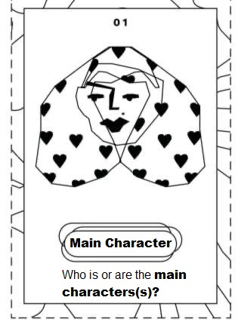
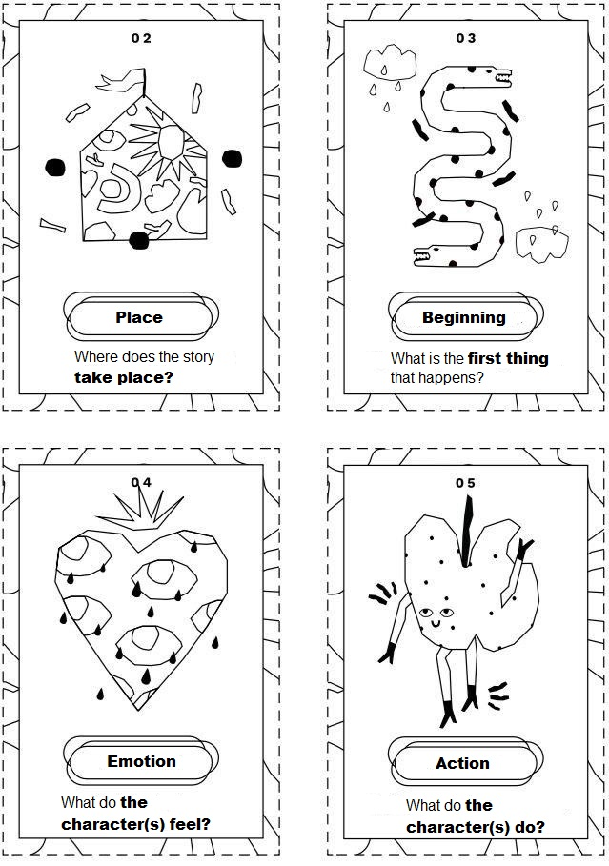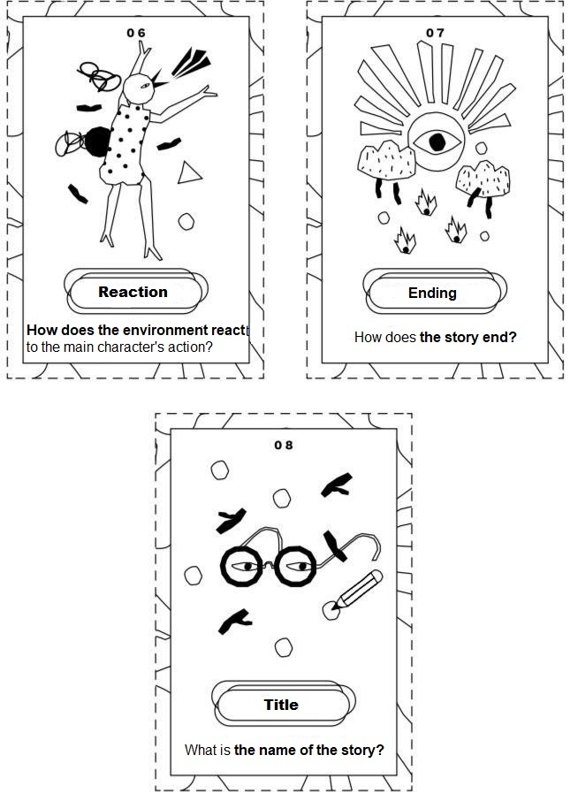
Claire Culliford (con Rosario Celis Ocaranza)

