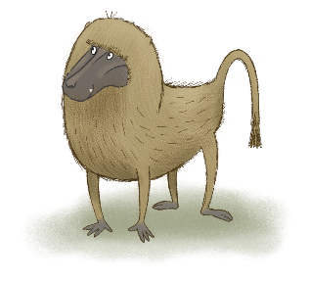
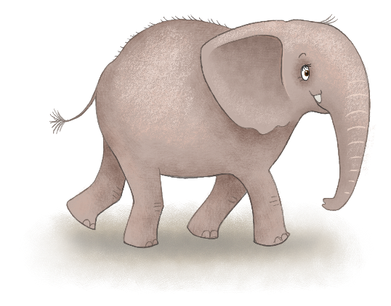
THE LITTLE HELPERS
My Favourite Animal – Activities for a School Day

What is your favourite wild animal?

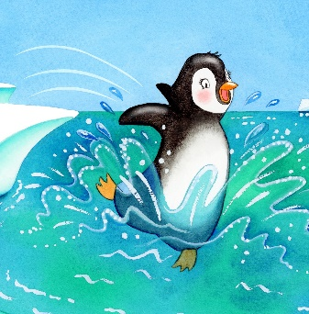
Why is it your favourite animal? Can you think of words to describe why you like it? (big, fierce, cuddly, gentle, lively, funny, quick, stealthy).

What animal category is your favourite animal in? [mammal, fish, amphibian, insect]

Can you draw a picture of your favourite animal, either by hand or using any technology you have available?
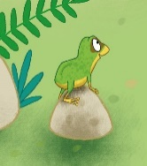
Where does your favourite animal usually live? Why does it live in this habitat in the wild? [food, space, biodiversity]

Which part of the world does your favourite animal live in? Does it live in just one or more than one country?
Are there lots of your favourite animal left on the planet?
Is it endangered in any way? If it is endangered, what is putting it at risk?
[damage to the environment and its habitat, poaching, lack of food]

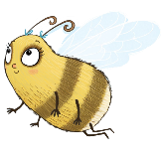
What does your favourite animal eat?
How much of this food do they usually eat in one day?
Can you find out how much this food costs?
What would it cost to feed your favourite animal for a day?

Can you write a story, a poem, a song, or all three things, about your favourite animal?
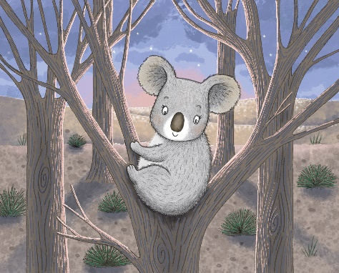
If you like creating other kinds of things – like paintings, crafts, computer images or games – can you create one of these things and include your favourite animal?

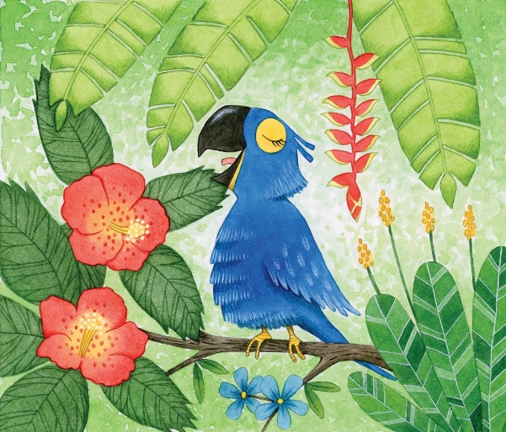

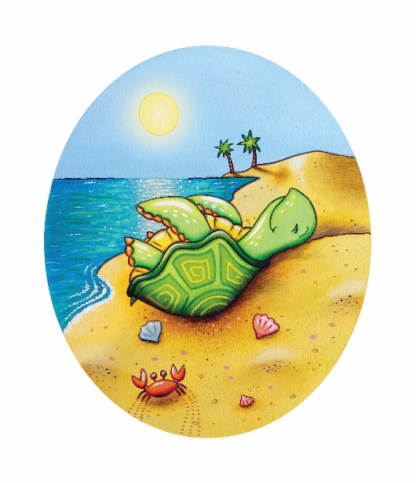

How could you help teach other people about your favourite animal?

Can you use produce an advertisement/poster to give people some important information about your favourite animal?

Will you create it on paper, or using technology?

Can you incorporate some of the information you have already collected into the advertisement?

Where would be a good place to put your advertisement so that people can see it? [school, newsagent, local shop, café, library, art gallery, park visitor centre, tourist information centre, an online wildlife forum]
