WORD MATCHING

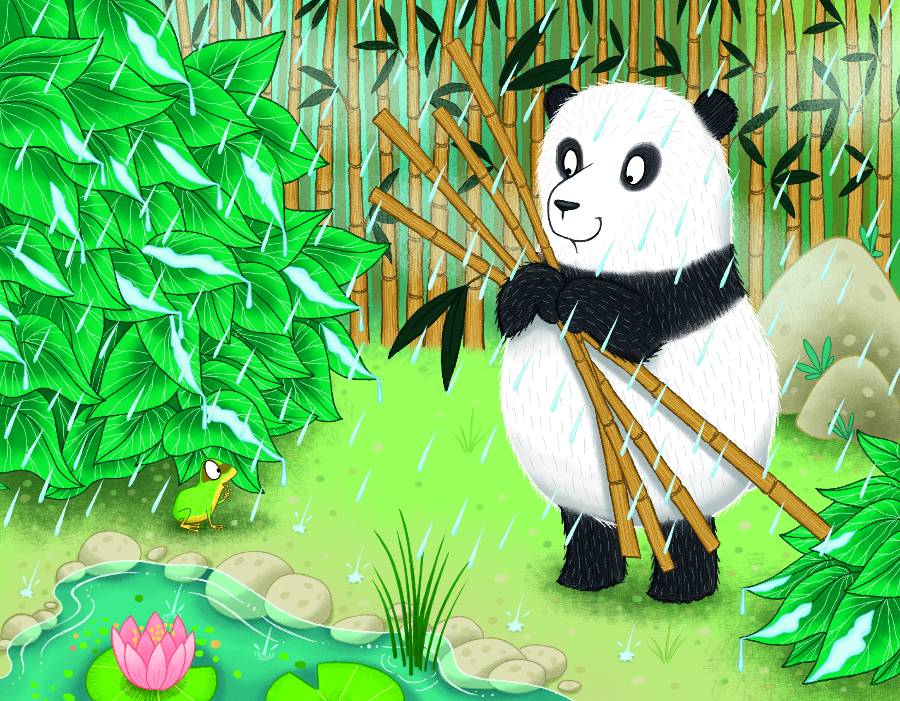

Match the following words with the pictures above:
panda frog
lily pad
bamboo acid rain

TRUE/FALSE

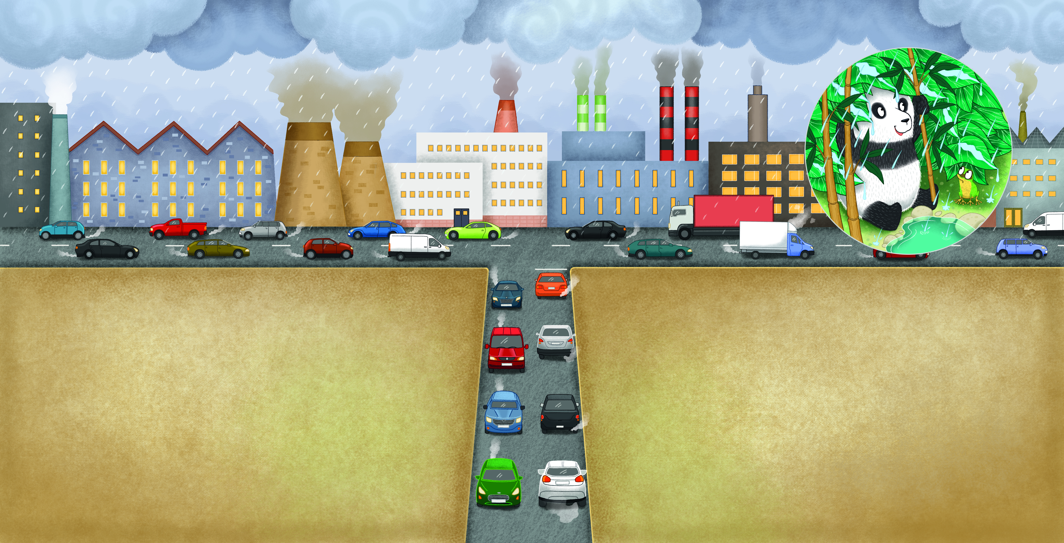
“Why does it matter if the rain has acid in it?” asks Pan Pan, a little confused.
“Mum and dad say that the chemicals in the acid in the rain can hurt us,” Fi Fi explains. “They can make it hard to fight off diseases and infections.”
Pan Pan is really shocked when he hears this.
“How do we get rid of the acid in the rain?” he asks.
“We can’t. My parents say that it’s caused by things like smoke from factories and exhaust fumes from cars. To get rid of the acid in the rain, humans need to stop the smoke and the fumes being created. The best us animals can do for now is to shelter from the rain when it comes.”
After reading this section of the story and looking at the picture, decide if the following sentences are true or false.
Acid rain is harmless for animals. TRUE/FALSE
Acid rain makes it easier for animals to fight off diseases and infections TRUE/FALSE
Acid rain is caused by things like factory smoke and car fumes. TRUE/FALSE
Animals can get rid of the acid in acid rain. TRUE/FALSE
Sheltering can help protect animals from acid rain. TRUE/FALSE
GAP FILL

“Why does it matter if the ____ has ____ in it?” asks Pan Pan, a little confused.
“Mum and dad say that the _________ in the acid in the rain can hurt us,” Fi Fi explains. “They can make it hard to fight off ________ and __________.”
Pan Pan is really shocked when he hears this.
“How do we get rid of the acid in the rain?” he asks.
“We can’t. My parents say that it’s caused by things like _____ from _________ and _______ _____ from cars. To get rid of the acid in the rain, humans need to stop the smoke and the _____ being created. The best us animals can do for now is to shelter from the rain when it comes.”

Choose the right words to fill in the gaps above.
chemicals infections factories
smoke x 2 acid fumes
exhaust fumes rain diseases
Vocabulary building – Can you find out the names of the gases that react with water to cause acid rain?

DRAWING PAGE
Can you draw your favourite picture from
Pan Pan Helps Shelter From Acid Rain?

WRITING PAGE
Can you write about your favourite part of
Pan Pan Helps Shelter From Acid Rain?

