SING-ALONG WITH EDDIE
Can you make up a tune to sing these words to?

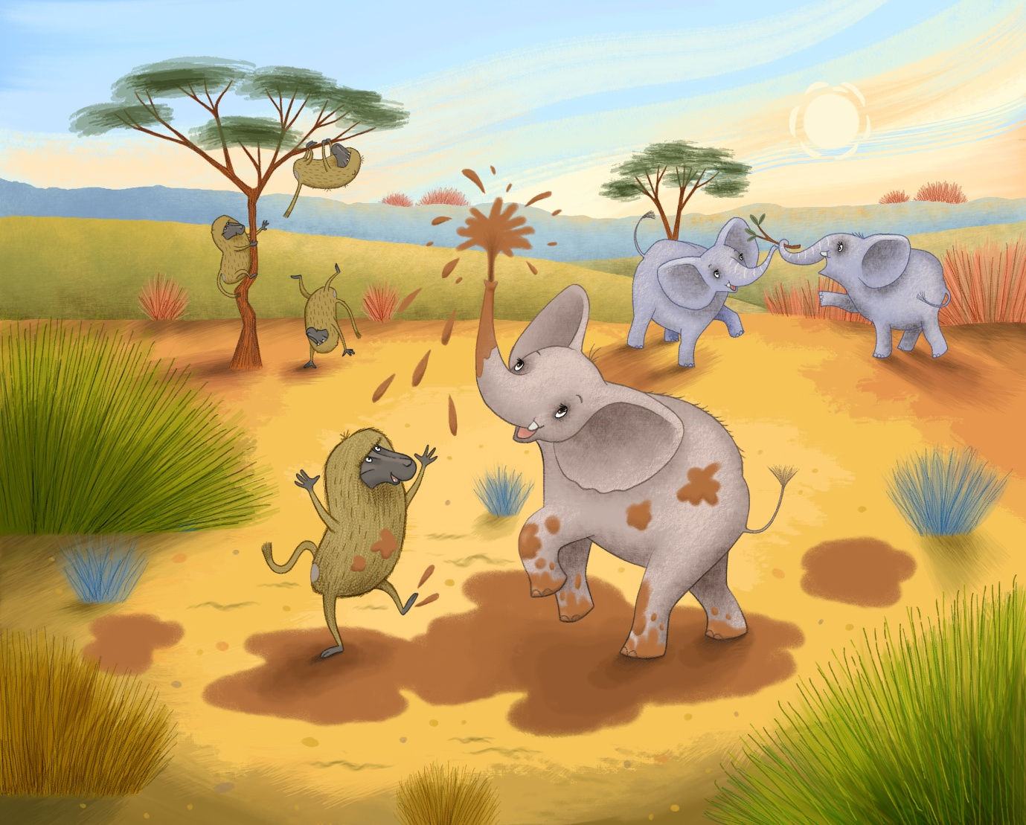

DROUGHT, DROUGHT, WHERE CAN WE FIND WATER?
LET’S STOP AND HAVE A THINK
I KNOW WE’LL DIG A WATERING HOLE
SO THAT WE ALL CAN DRINK!

