SING-ALONG WITH EDDIE
Can you make up a tune to sing these words to?

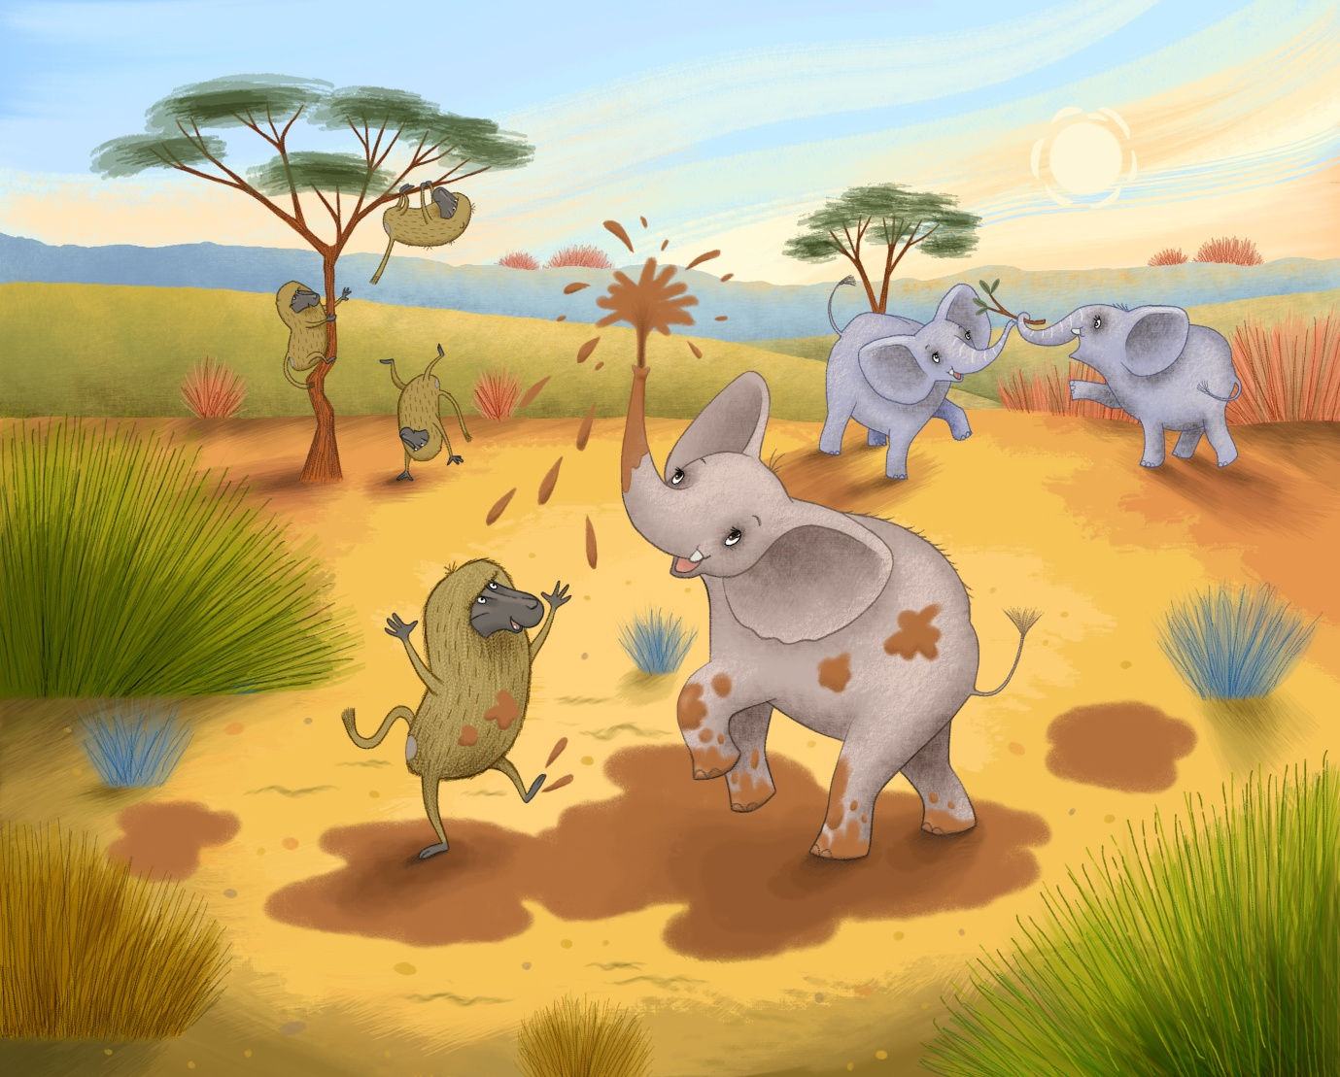

ELEPHANT, ELEPHANT, ELEPHANT, MUD
ELEPHANT, MUD
ELEPHANT, MUD
ELEPHANT, ELEPHANT, ELEPHANT, MUD
ELEPHANT, BABOON, MUD

