Word matching

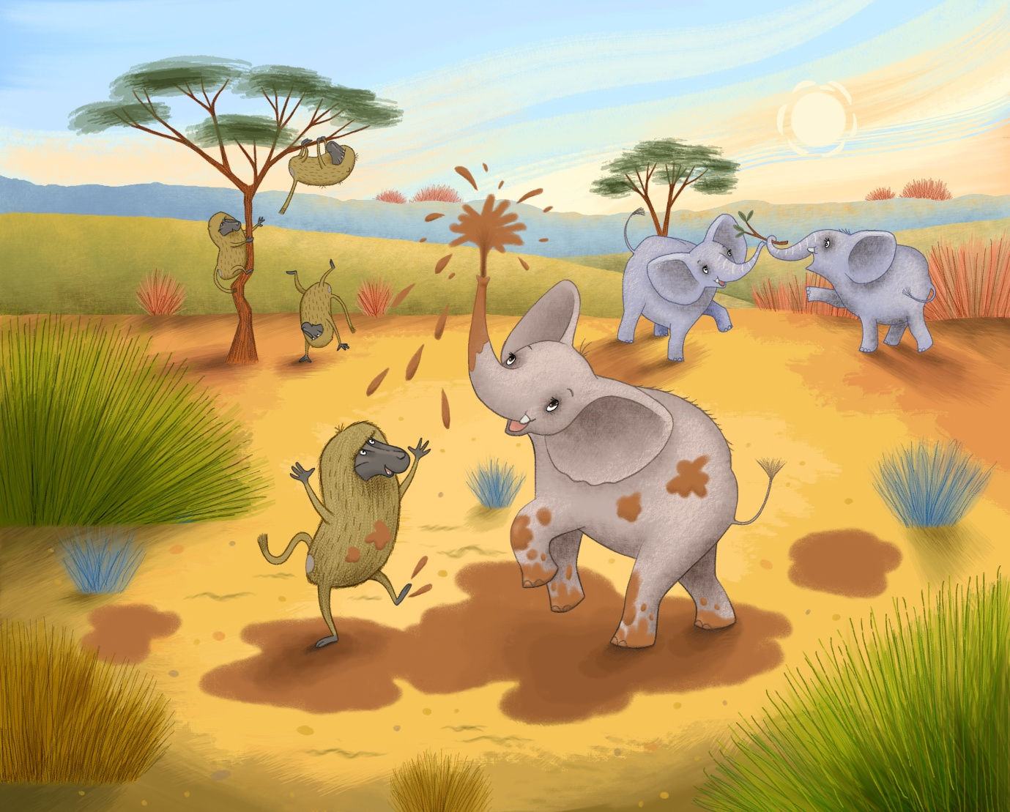

Match the following words with the pictures above:

elephant savannah

mud

baboon grasses

READING COMPREHENSION
"Eddie, I'm so glad I've bumped into you. I've been trying to get a drink as it's so hot. I can't find a watering hole anywhere. I'm really, really thirsty."
"Oh no!" said Eddie. "Does anyone else in your family know where there's a watering hole?"
"That's just the problem," replied Oscar. "None of us can find water anywhere. My dad says we're suffering from a complete drought. He says we've not had rain for such a long time that the ground is all hard and dry."
Eddie, not liking to see his friend so upset, sits down on his big bottom, to have a think.
But he doesn’t sit down for long because he has an idea!

After reading this section of the story, can you try and answer these questions?

- Why do Oscar and his family need water?

- Why can they not find a watering hole?

- Do you like thinking up new ideas? Why?
DRAWING PAGE
Can you draw your favourite picture from
Eddie Helps Locate Water?

WRITING PAGE
Can you write about your favourite part of
Eddie Helps Locate Water?

