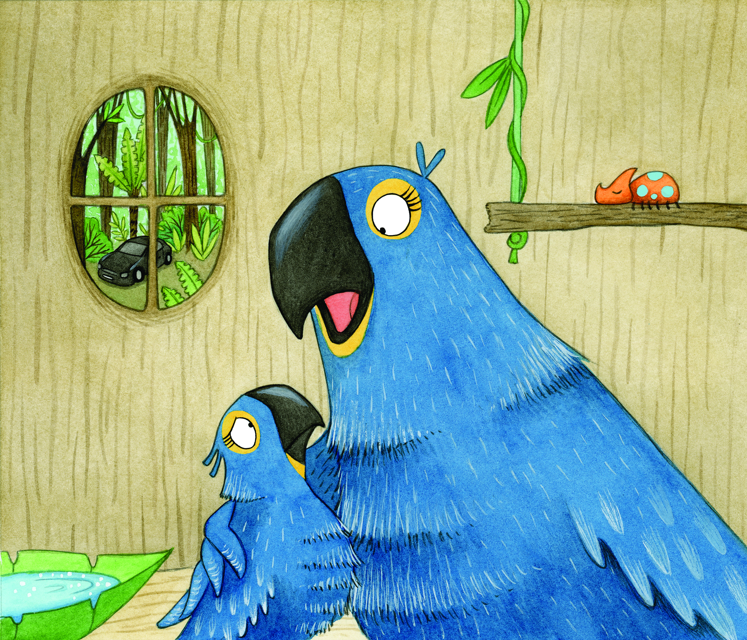
SING-ALONG WITH BELLA
Can you make up a tune to sing these phrases to?

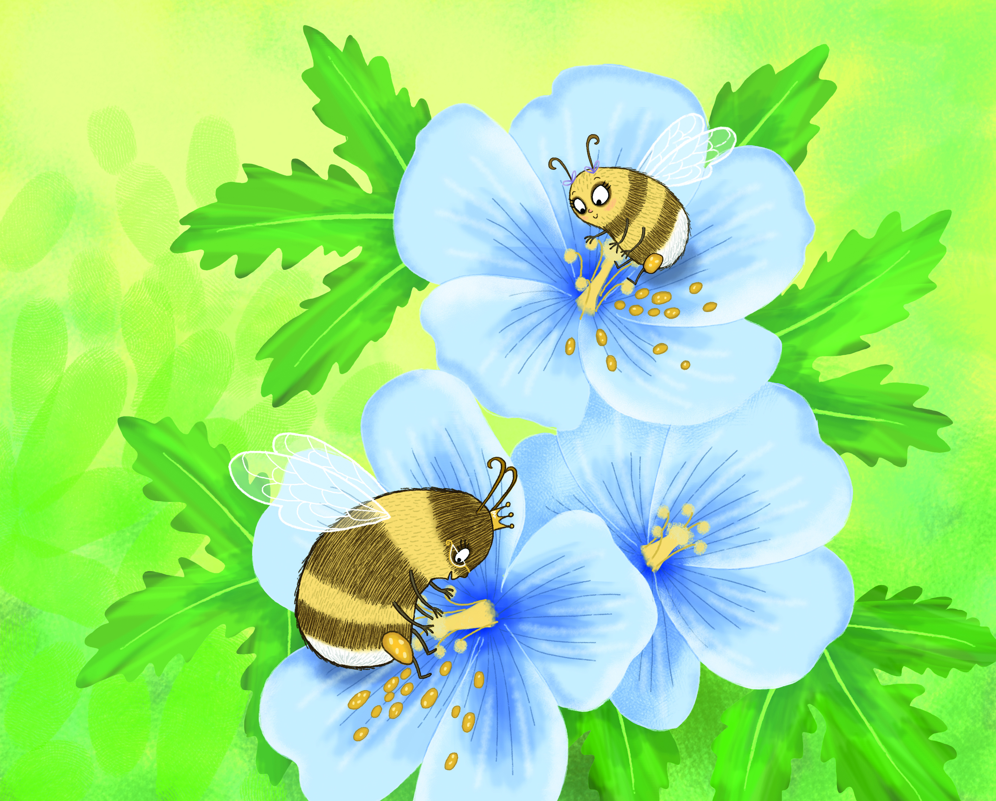

BUMBLE BEES IN THE GARDEN,
BUMBLE BEES IN THE GARDEN
BUZZING AROUND FOR HOURS
BUMBLE BEES IN THE GARDEN
BUMBLE BEES IN THE GARDEN
POLLINATING THE FLOWERS

