SING-ALONG WITH BELLA
Can you make up a tune to sing these words to?
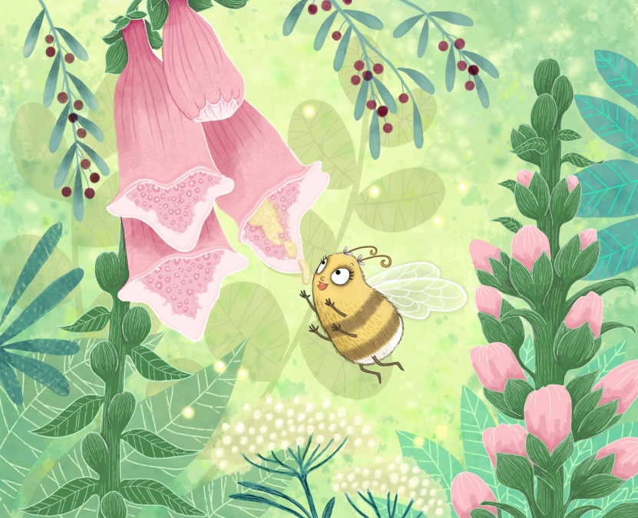

BUMBLE BEE, BUMBLE BEE, BUMBLE BEE, FLOWER
BUMBLE BEE, FLOWER
BUMBLE BEE, FLOWER
BUMBLE BEE, POLLEN, FLOWER

