WORD MATCHING – Page 12
Within just a few weeks, new flowers start to appear in the garden. The bees collect the pollen from them, dropping it into other flowers. Within a few months, the garden looks just like it used to. It is full of colourful flowers and buzzing bees.
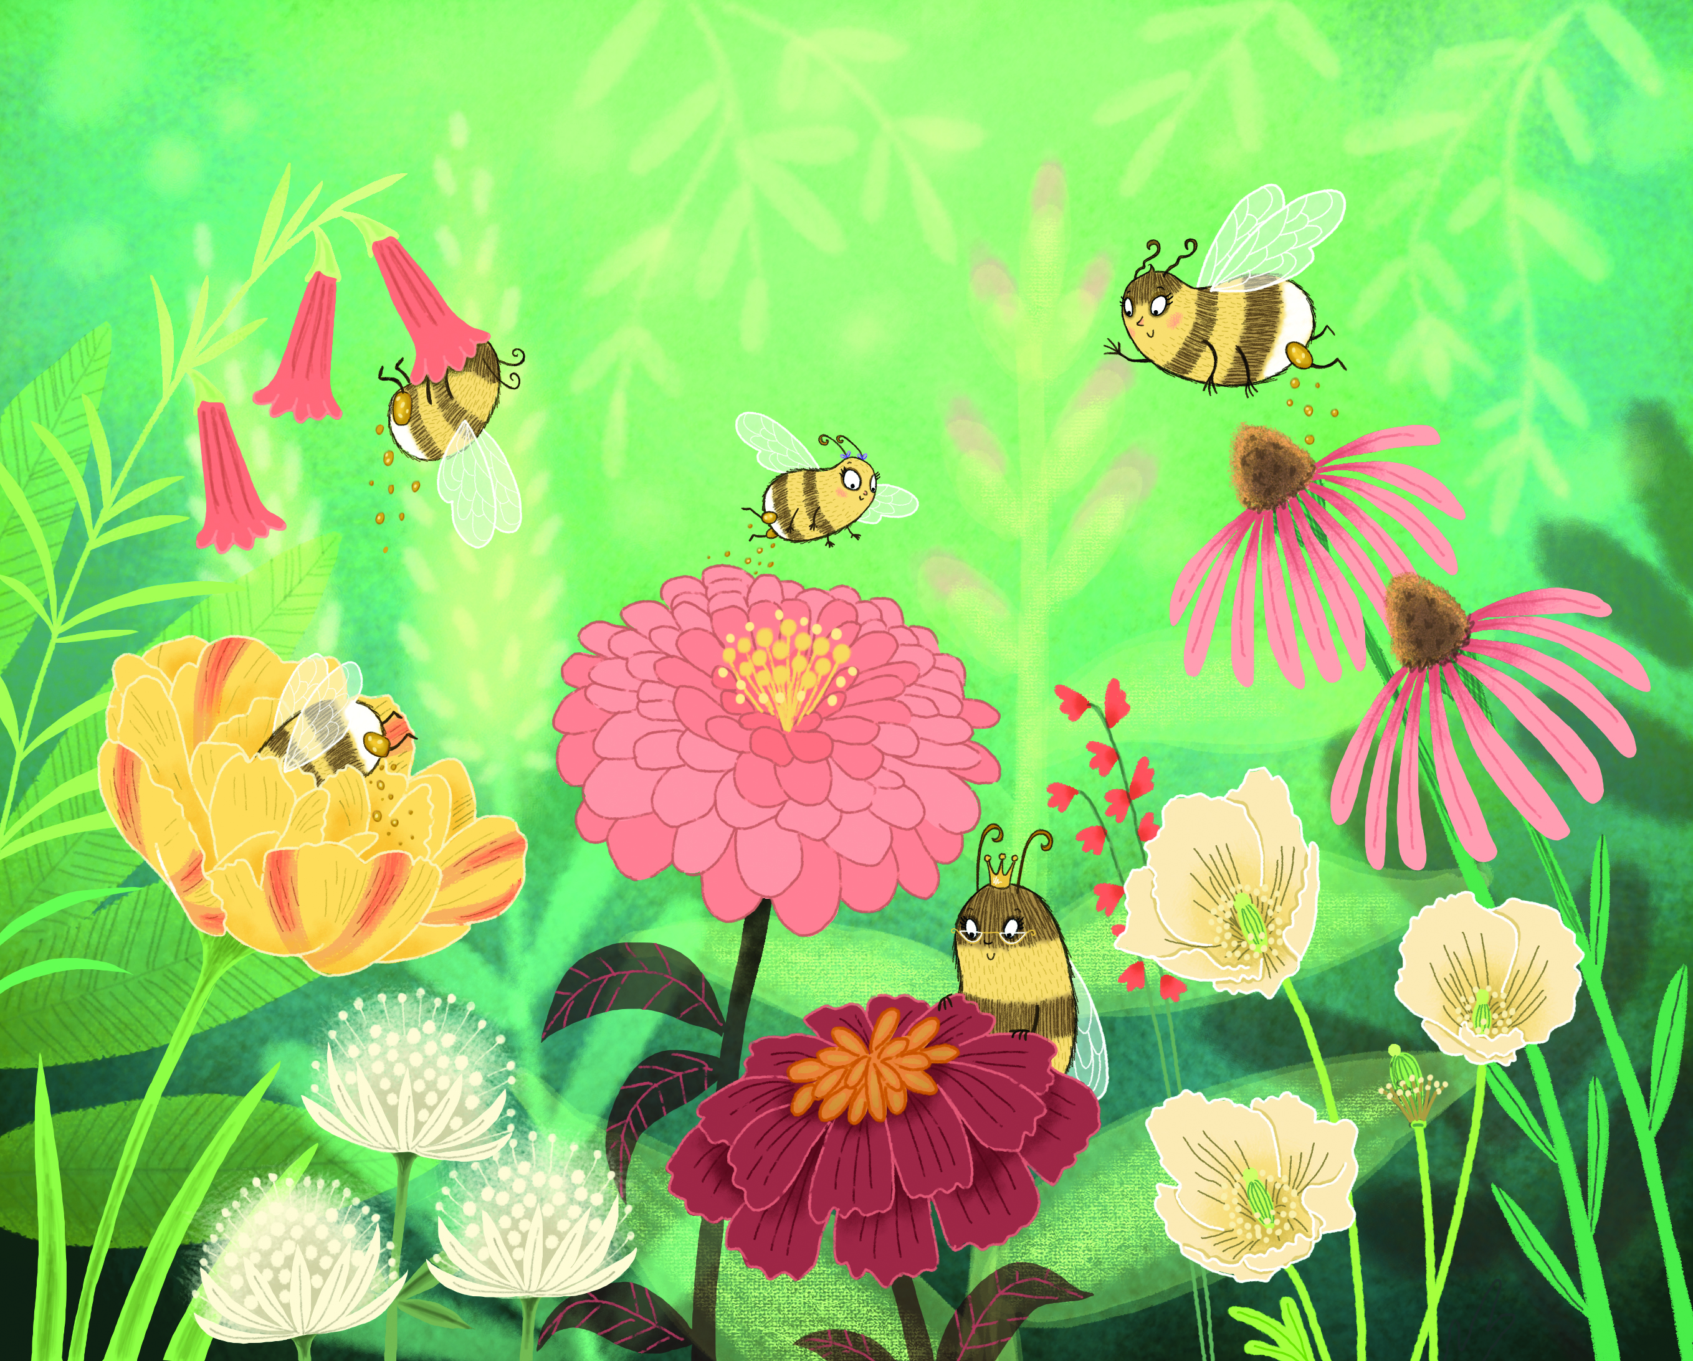

Match the following words with the picture above:

Flower Pollen sac
Worker bee

Queen bee Pollen

GAP FILL – Page 7
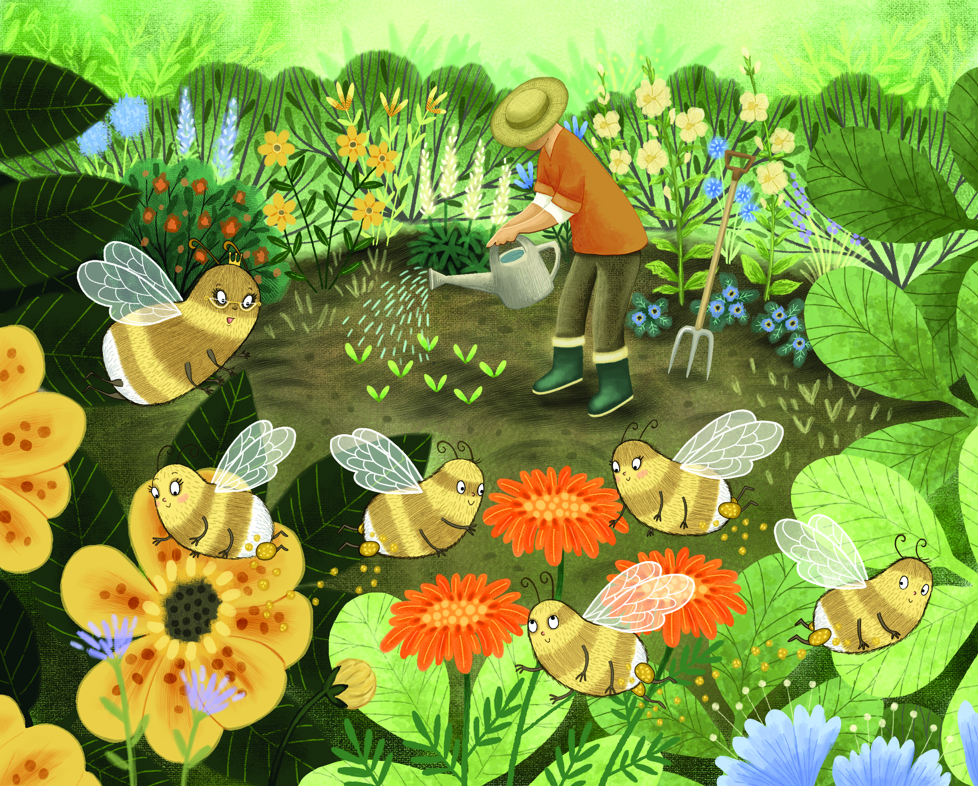

“Oh no!” cries Bella, upset. “But I love our garden. How can we get the flowers back, grandma?”
“Well,” says Bonnie, “if a new __________ waters the flowers, that will help. Or he could ______ more new flowers. Then there’s _______________ . That happens whilst we’re collecting nectar. ______ grains from the ______ part of some flowers get stuck in the little hairs on our bodies and then fall onto the ________ part of other flowers. That process helps create new flowers too.”
Choose the right words to fill in the gaps above.
plant pollination female
pollen male gardener

TRUE/FALSE EXERCISE
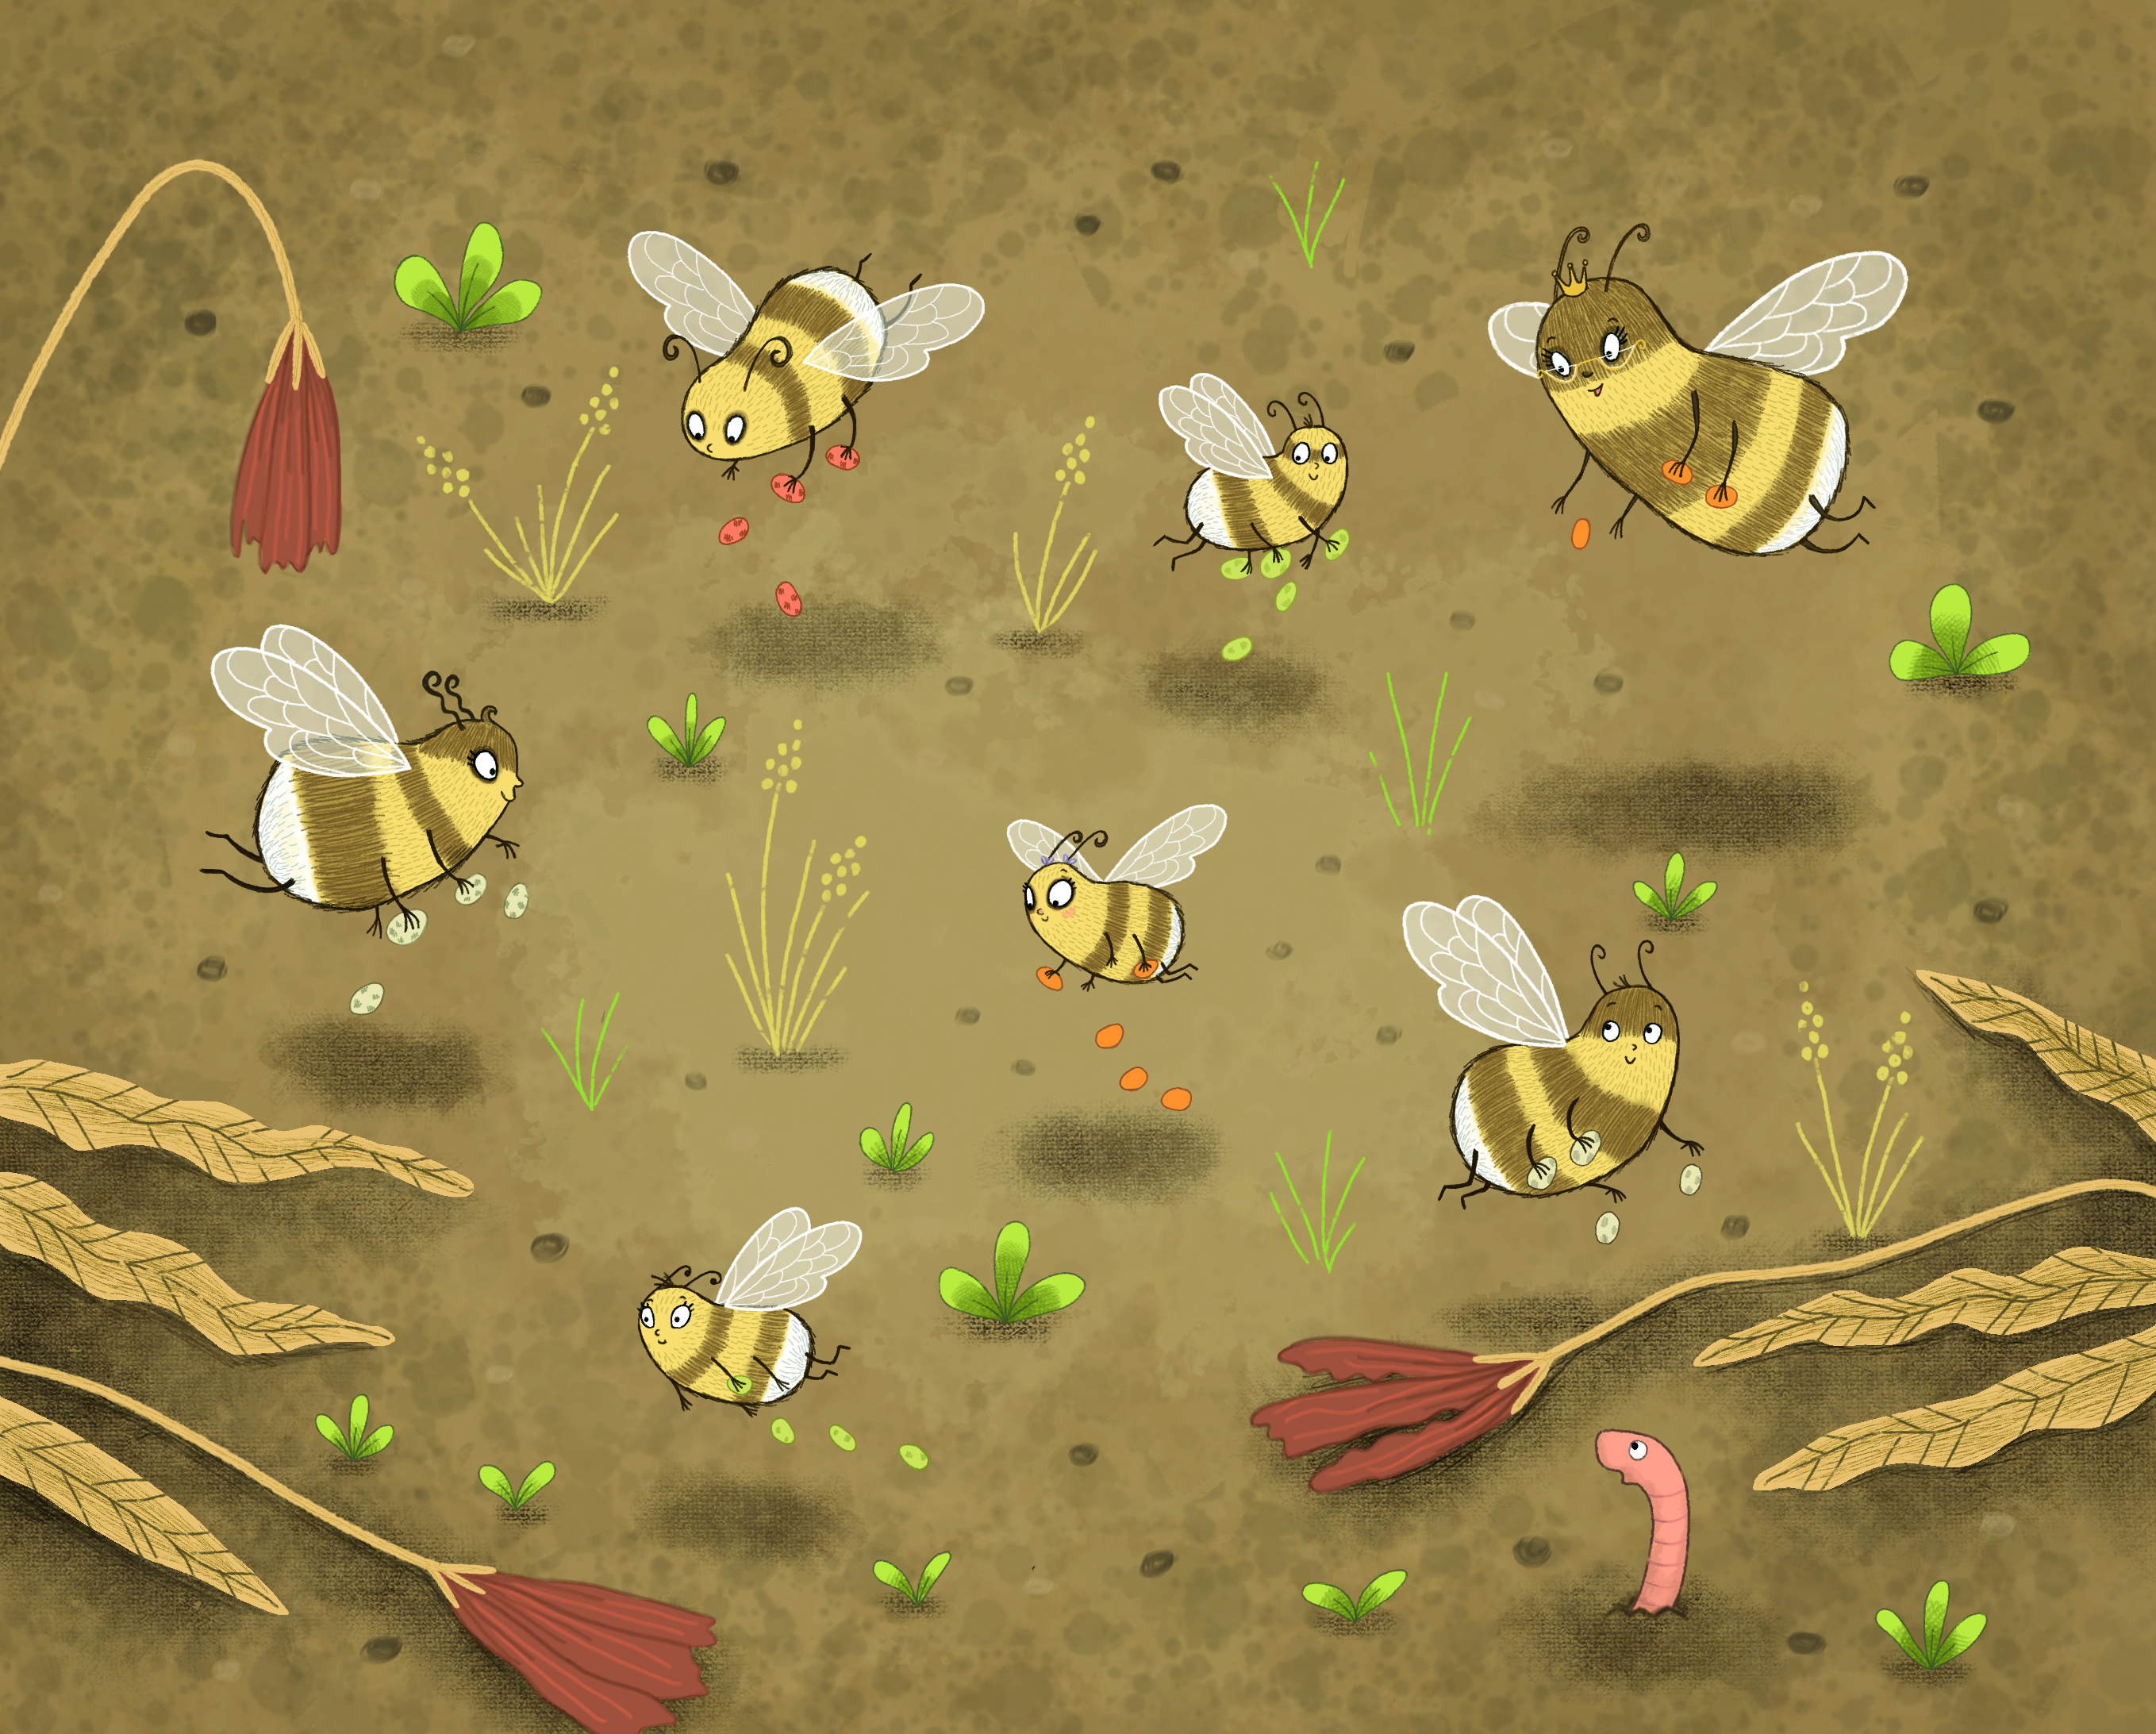

After reading the story, decide if the following sentences are true or false.

Worker bees are female. TRUE/FALSE
Pollenation involves pollen grains from the male part of some flowers being transported to the male part of other flowers. TRUE/FALSE
Pollination creates new flowers. TRUE/FALSE
Bees carry pollen in pollen boxes. TRUE/FALSE
Bees are the only insects who are pollinators. TRUE/FALSE
Pollinators are vital for producing healthy crops for food and other products. TRUE/FALSE
DRAWING PAGE
Can you draw
your favourite picture from
Bella Helps Increase Pollination?

WRITING PAGE
Can you write about
your favourite part of
Bella Helps Increase Pollination?

