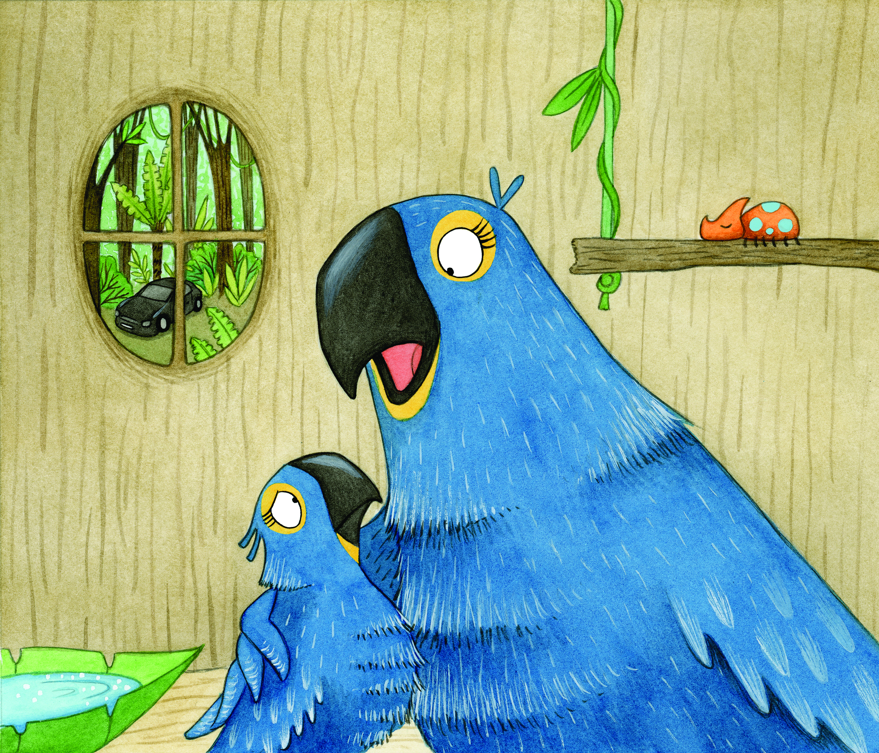
SING-ALONG WITH KATI
Can you make up a tune to sing these phrases to?

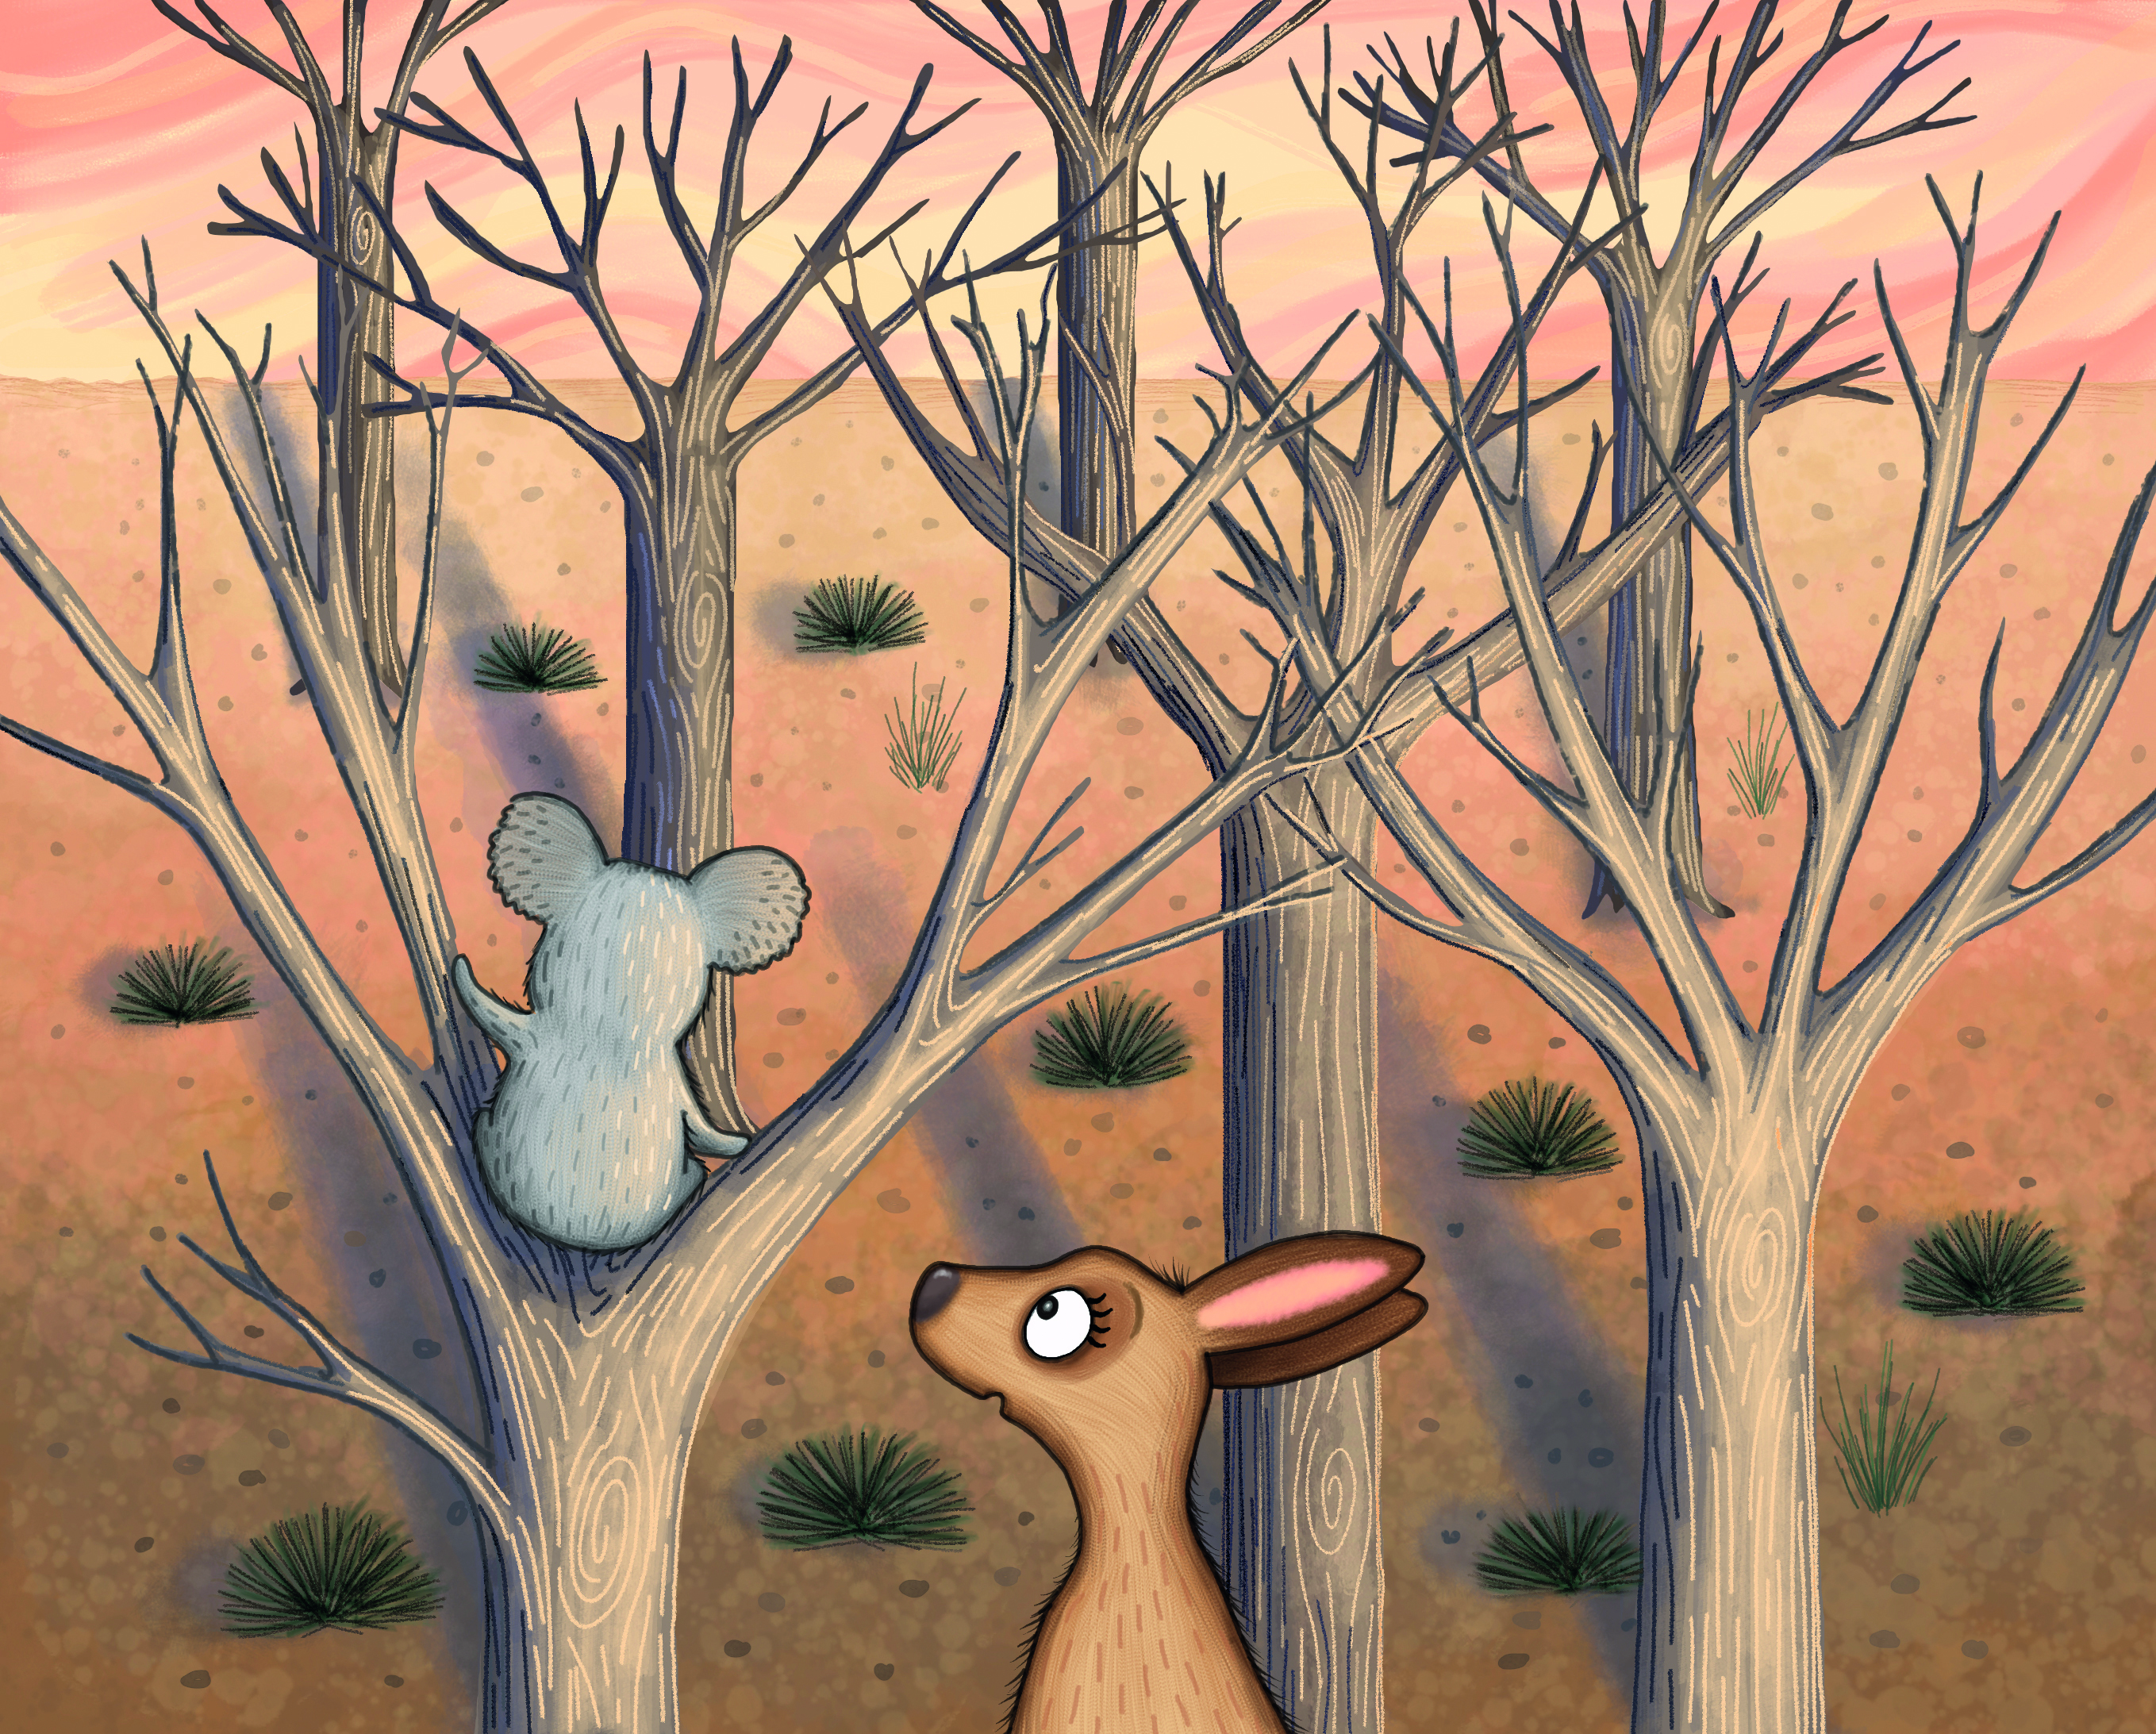

EUCALYPTUS LEAVES ARE GONE, EUCALYPTUS LEAVES ARE GONE
LET’S NOT ADMIT DEFEAT
EUCALYPTUS LEAVES ARE GONE, EUCALYPTUS LEAVES ARE GONE
WE’LL HELP KOALAS FIND MORE TO EAT

