SING-ALONG WITH KATI
Can you make up a tune to sing these words to?
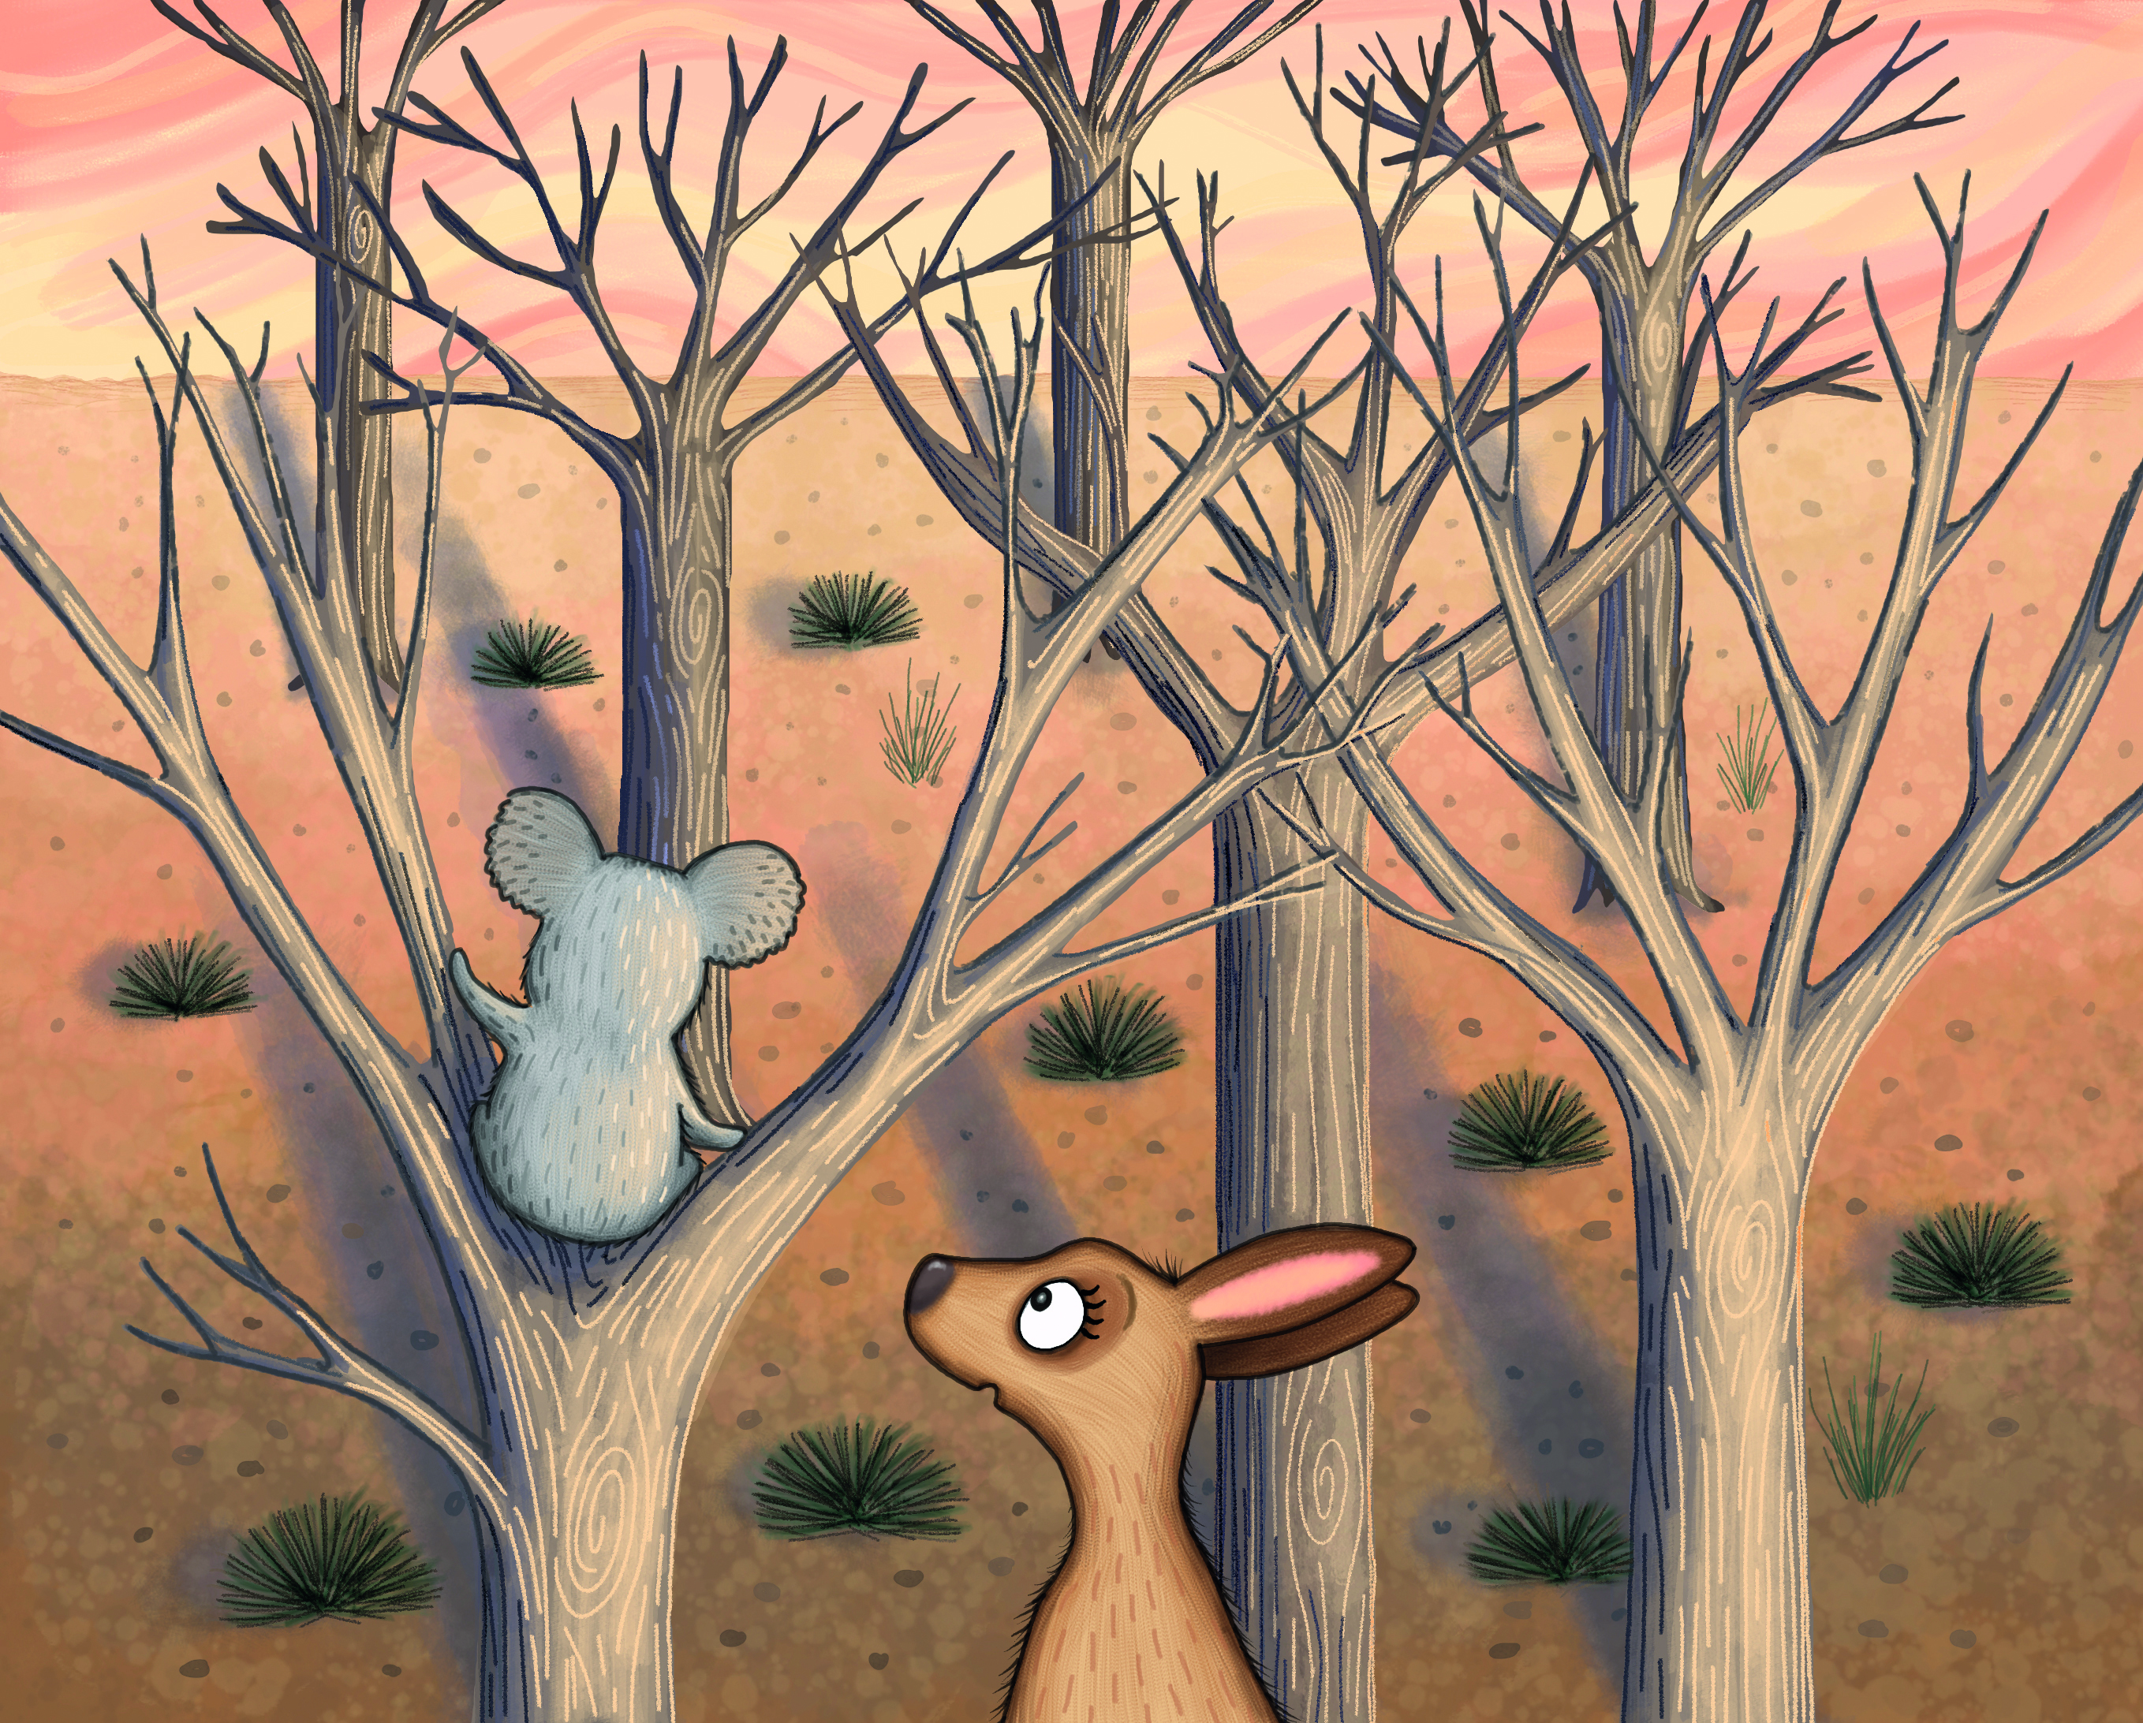

KOALA, KOALA, KOALA, EUCALYPTUS
KOALA, EUCALYPTUS
KOALA, EUCALYPTUS
KOALA, KOALA, KOALA, EUCALYPTUS
KOALA, EUCALYPTUS, KANGAROO

