WORD MATCHING – Page 3

Tyler loves swimming in the sea. He plays with the other turtles, the pretty-coloured fish and the octopuses with their long dangly tentacles.
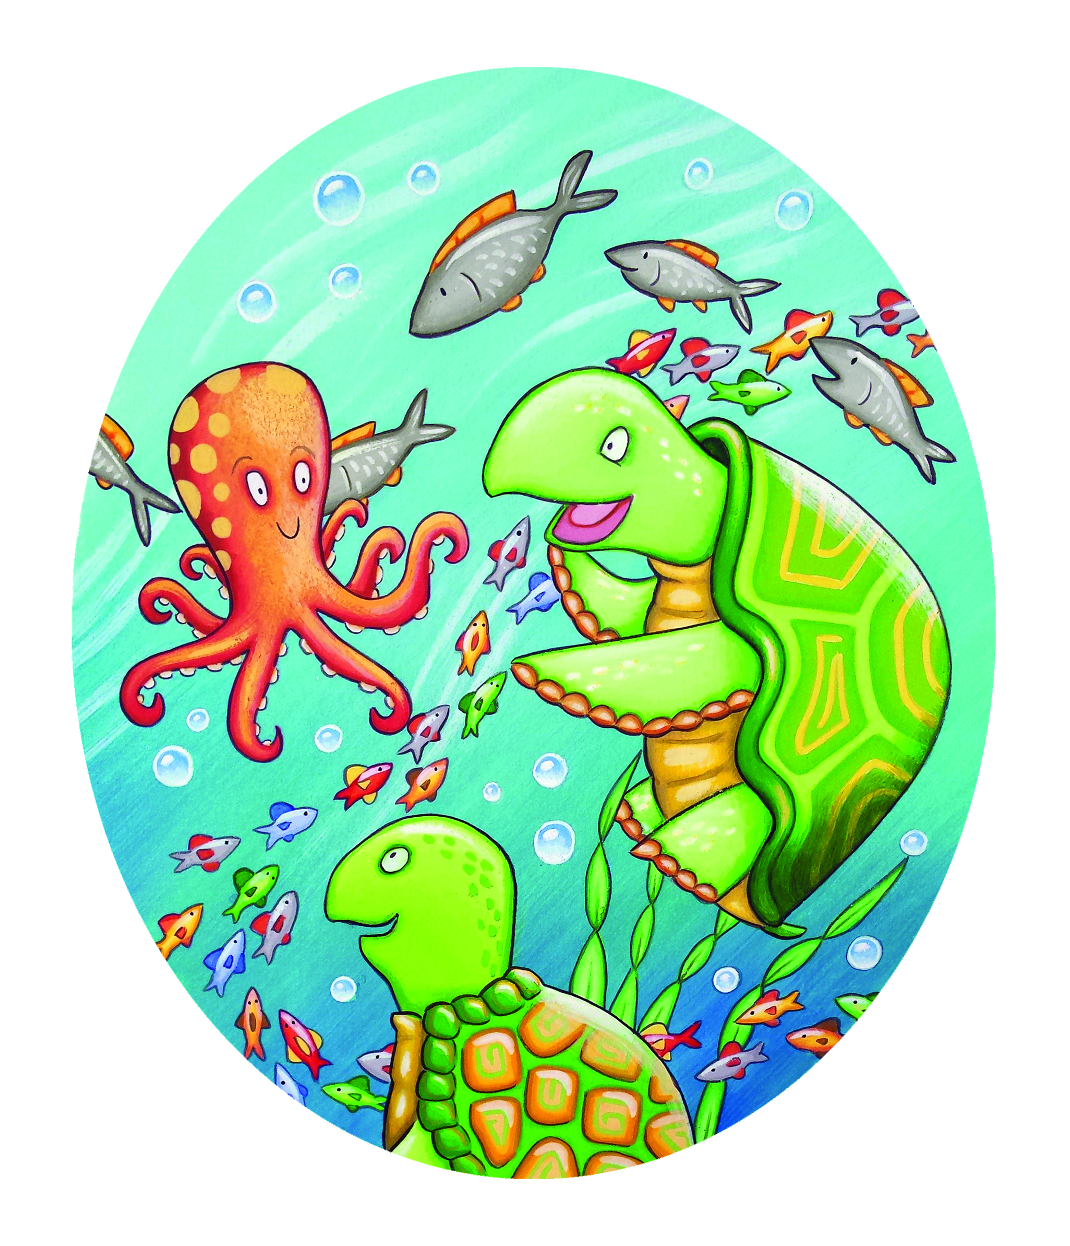

Match the following words with the pictures above:

Fish Turtle Octopus
Seaweed Air bubble
TRUE/FALSE EXERCISE – Page 6
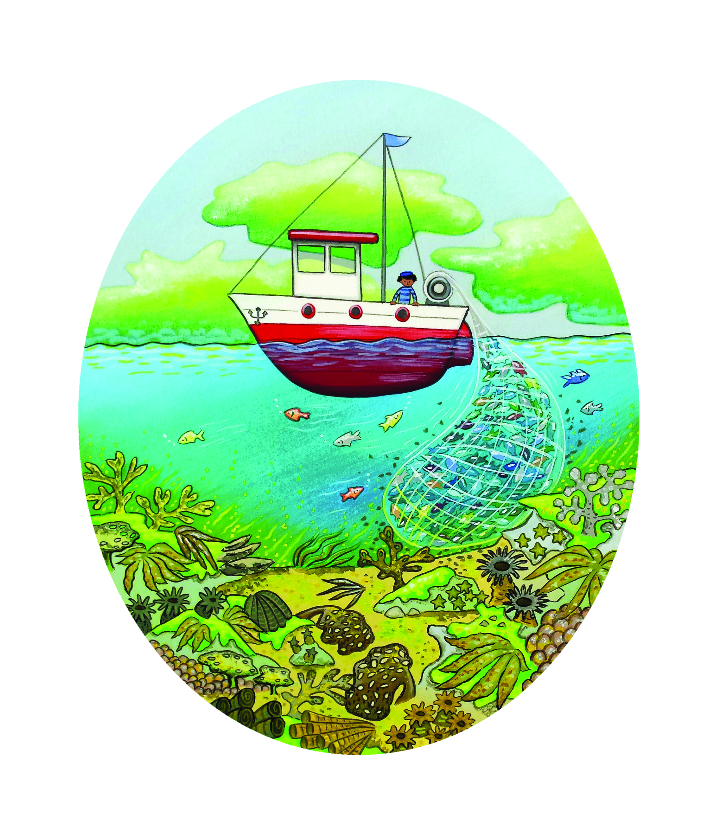
"Oh no!" says Tyler, shocked. "But your home is so pretty. Why is it disappearing?"
"Mum and dad say there are lots of reasons. People are fishing too much and there's air pollution. The coral gets diseases too, which doesn't help," explains Finn. "I don't know what we're going to do."

After reading this page and looking at the picture, decide if the following sentences are true or false.
Fish live in nets. TRUE/FALSE
Fish live in the coral reef. TRUE/FALSE
The coral reef is black. TRUE/FALSE
The coral reef is different colours. TRUE/FALSE
The coral reef is disappearing. TRUE/FALSE
Fish are making the coral reef disappear. TRUE/FALSE
Air pollution is good. TRUE/FALSE
DRAWING PAGE
Can you draw your favourite picture from
Tyler Helps Find A New Home?

WRITING PAGE
Can you write about your favourite part of
Tyler Helps Find A New Home?

