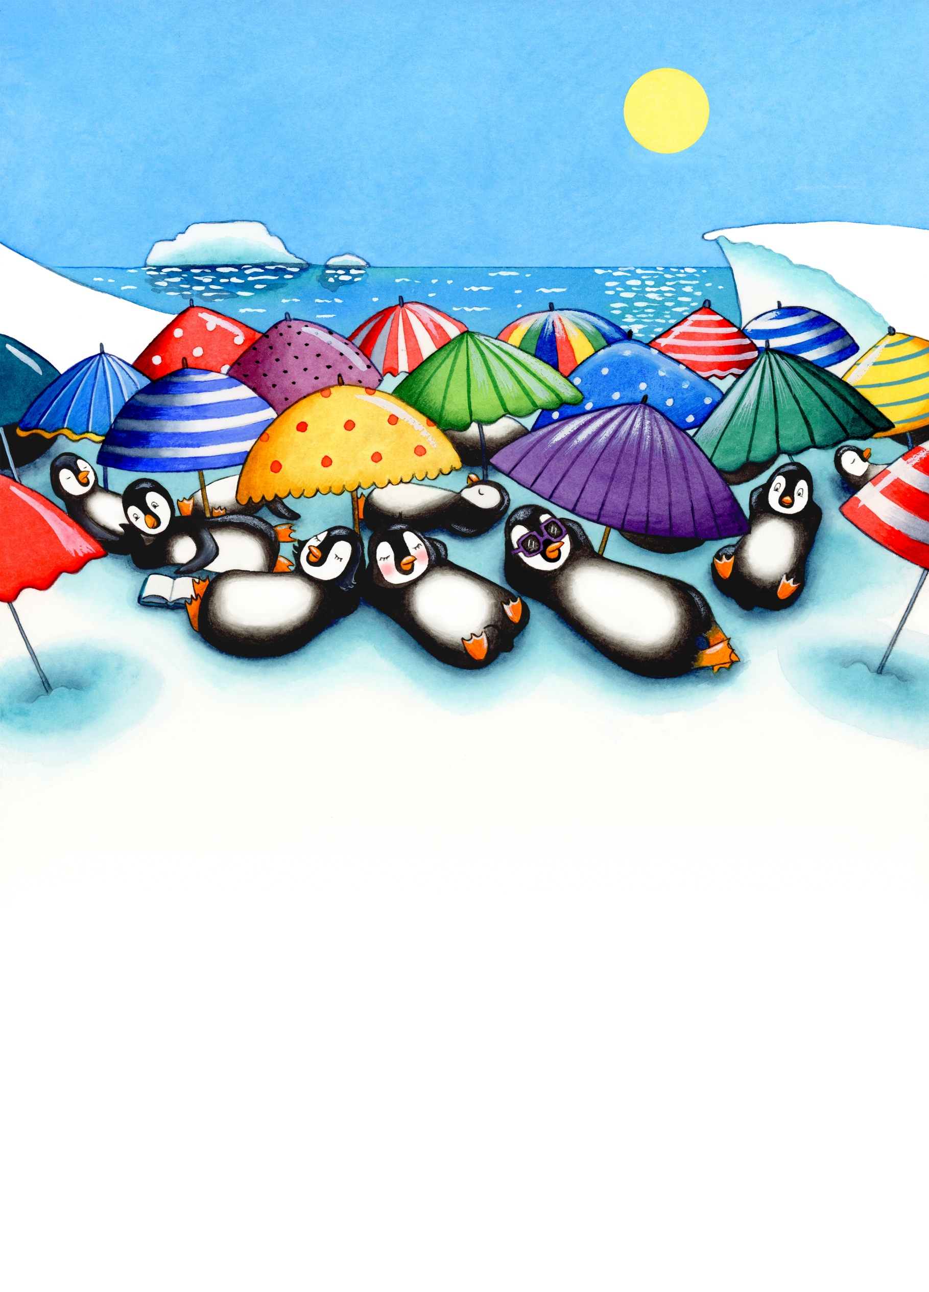

**SING-ALONG WITH PENNY**

**Can you make up a tune to sing these words to?**

**MELTING ICE CAPS, MELTING ICE CAPS**

**LET’S STOP THEM BEING WARM**

**MELTING ICE CAPS, MELTING ICE CAPS**

**SO OUR HOME COMES TO NO HARM**