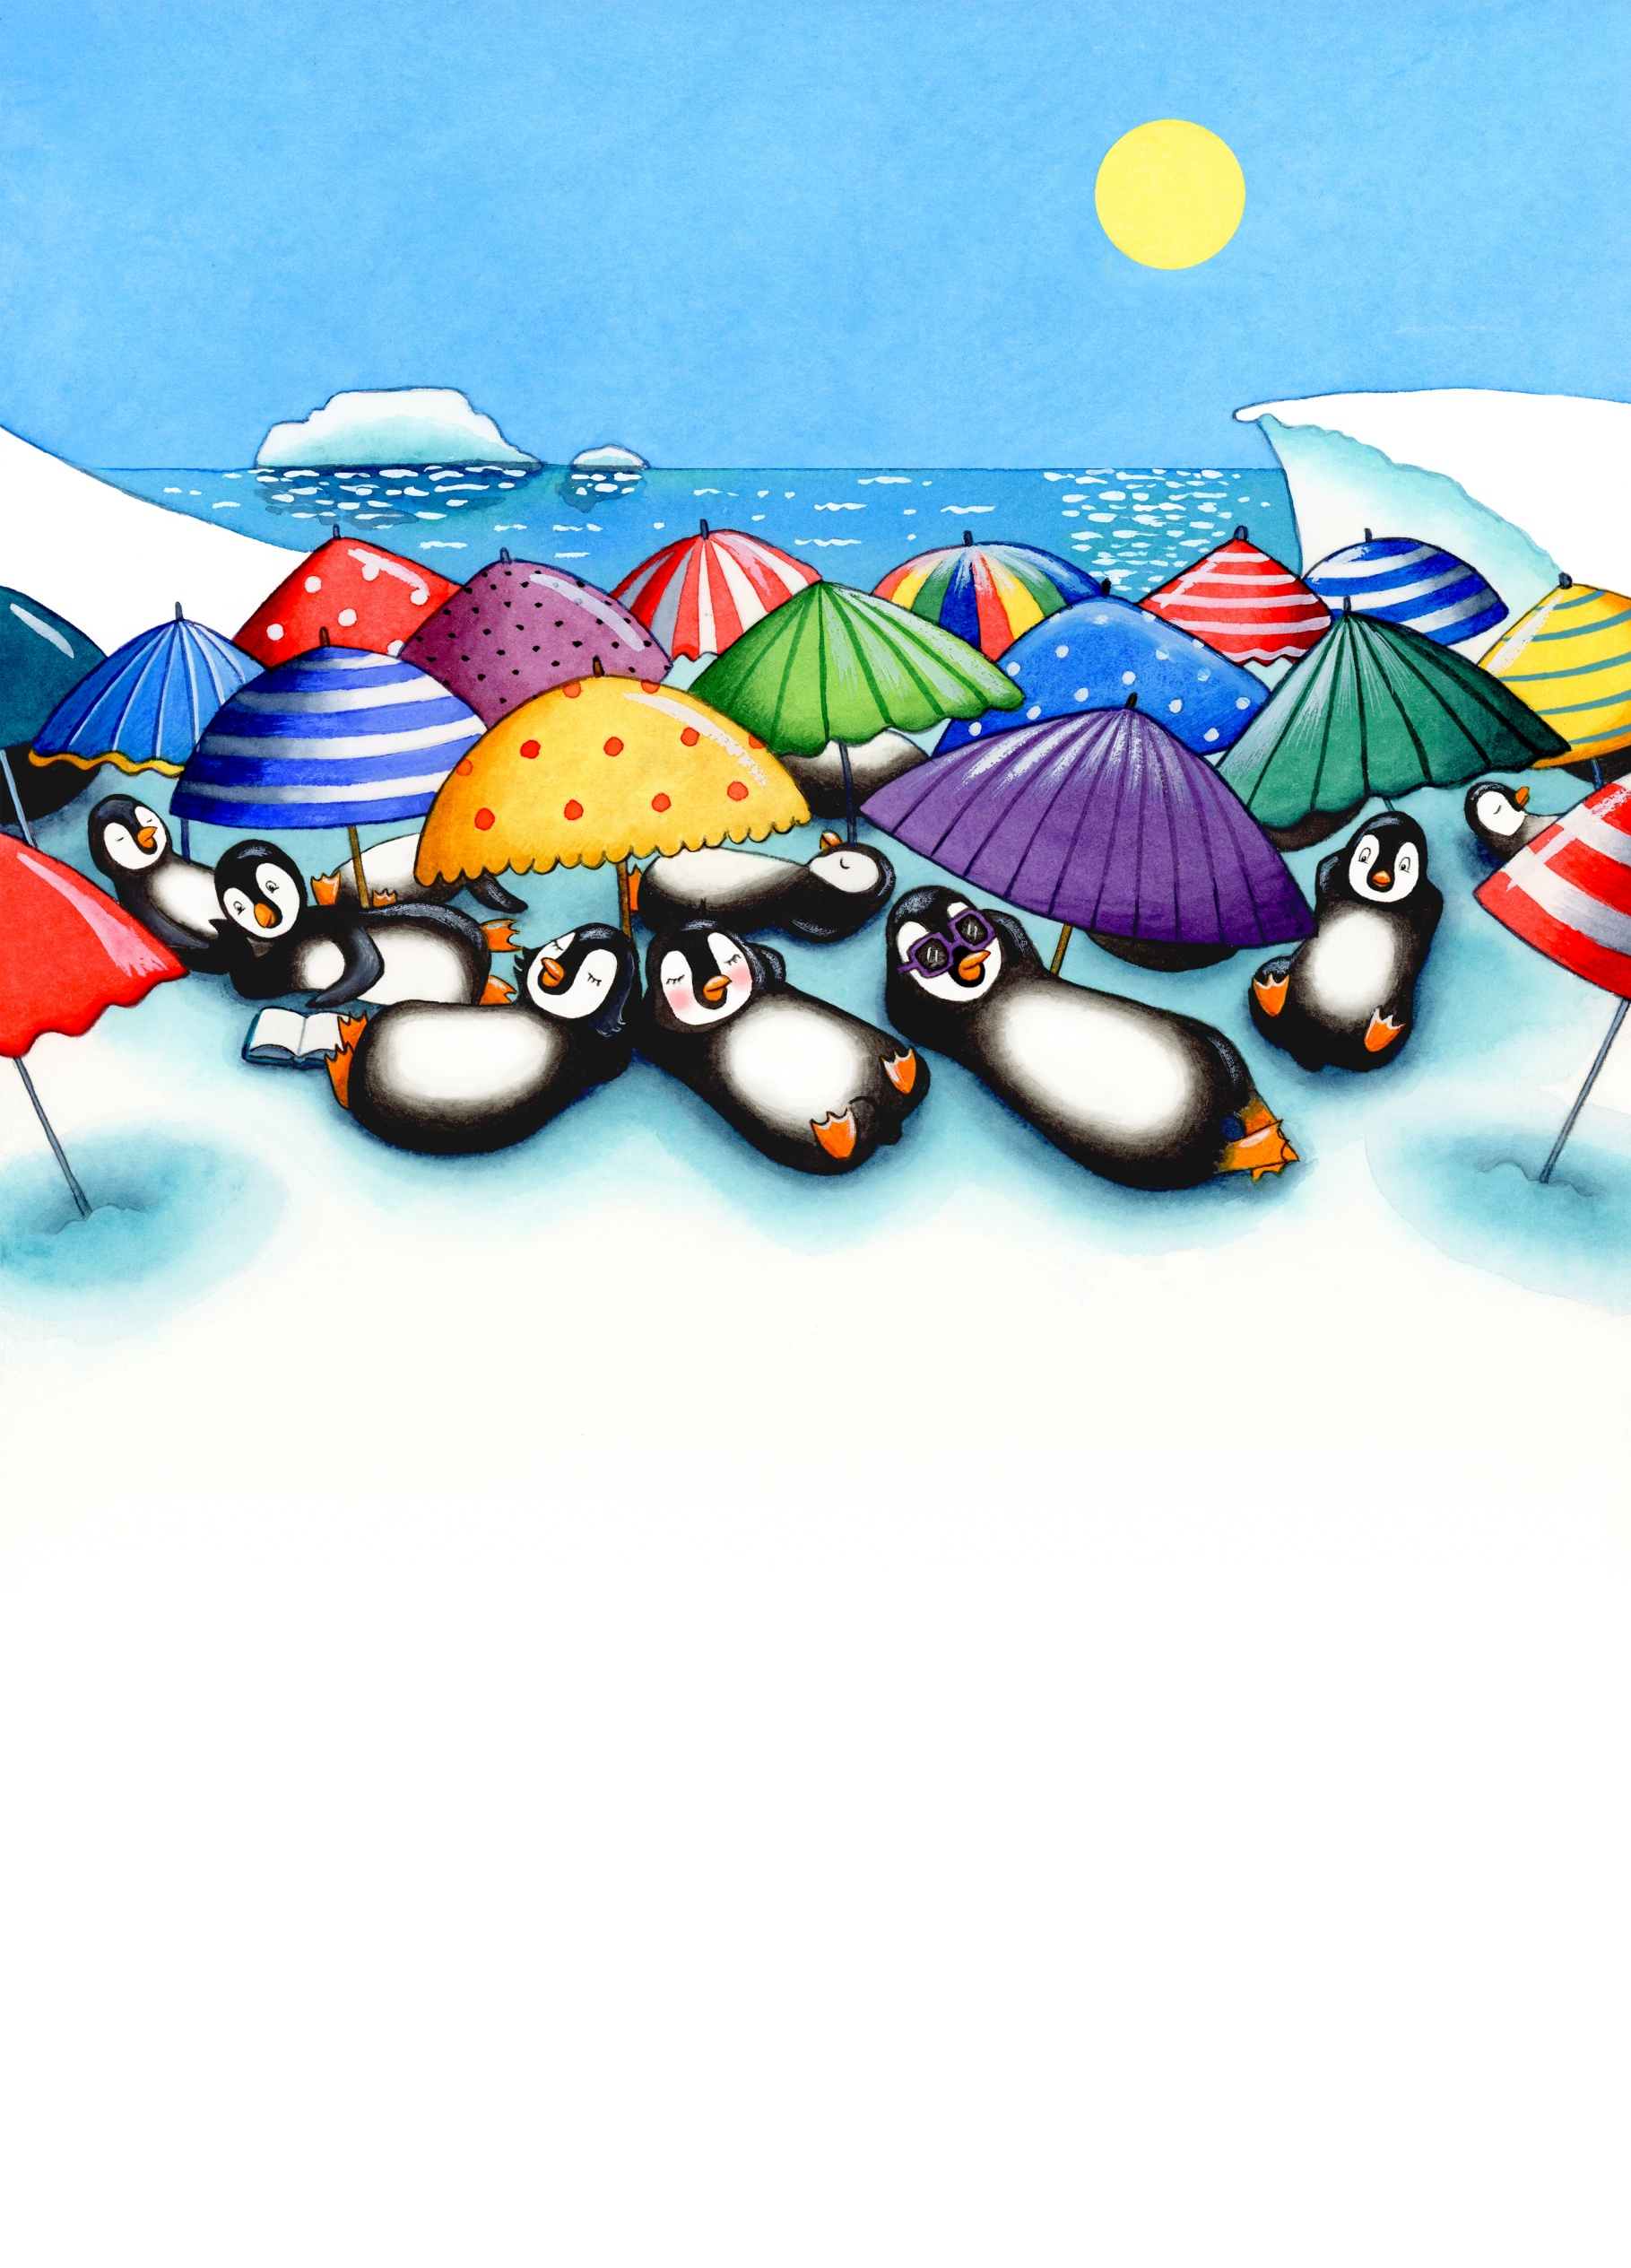

**SING-ALONG WITH PENNY**

**Can you make up a tune to sing these words to?**

**PENGUIN, PENGUIN, PENGUIN, ICE**

**PENGUIN, ICE**

**PENGUIN, ICE**

**PENGUIN, PENGUIN, PENGUIN, ICE**

**PENGUIN, MELTING ICE**