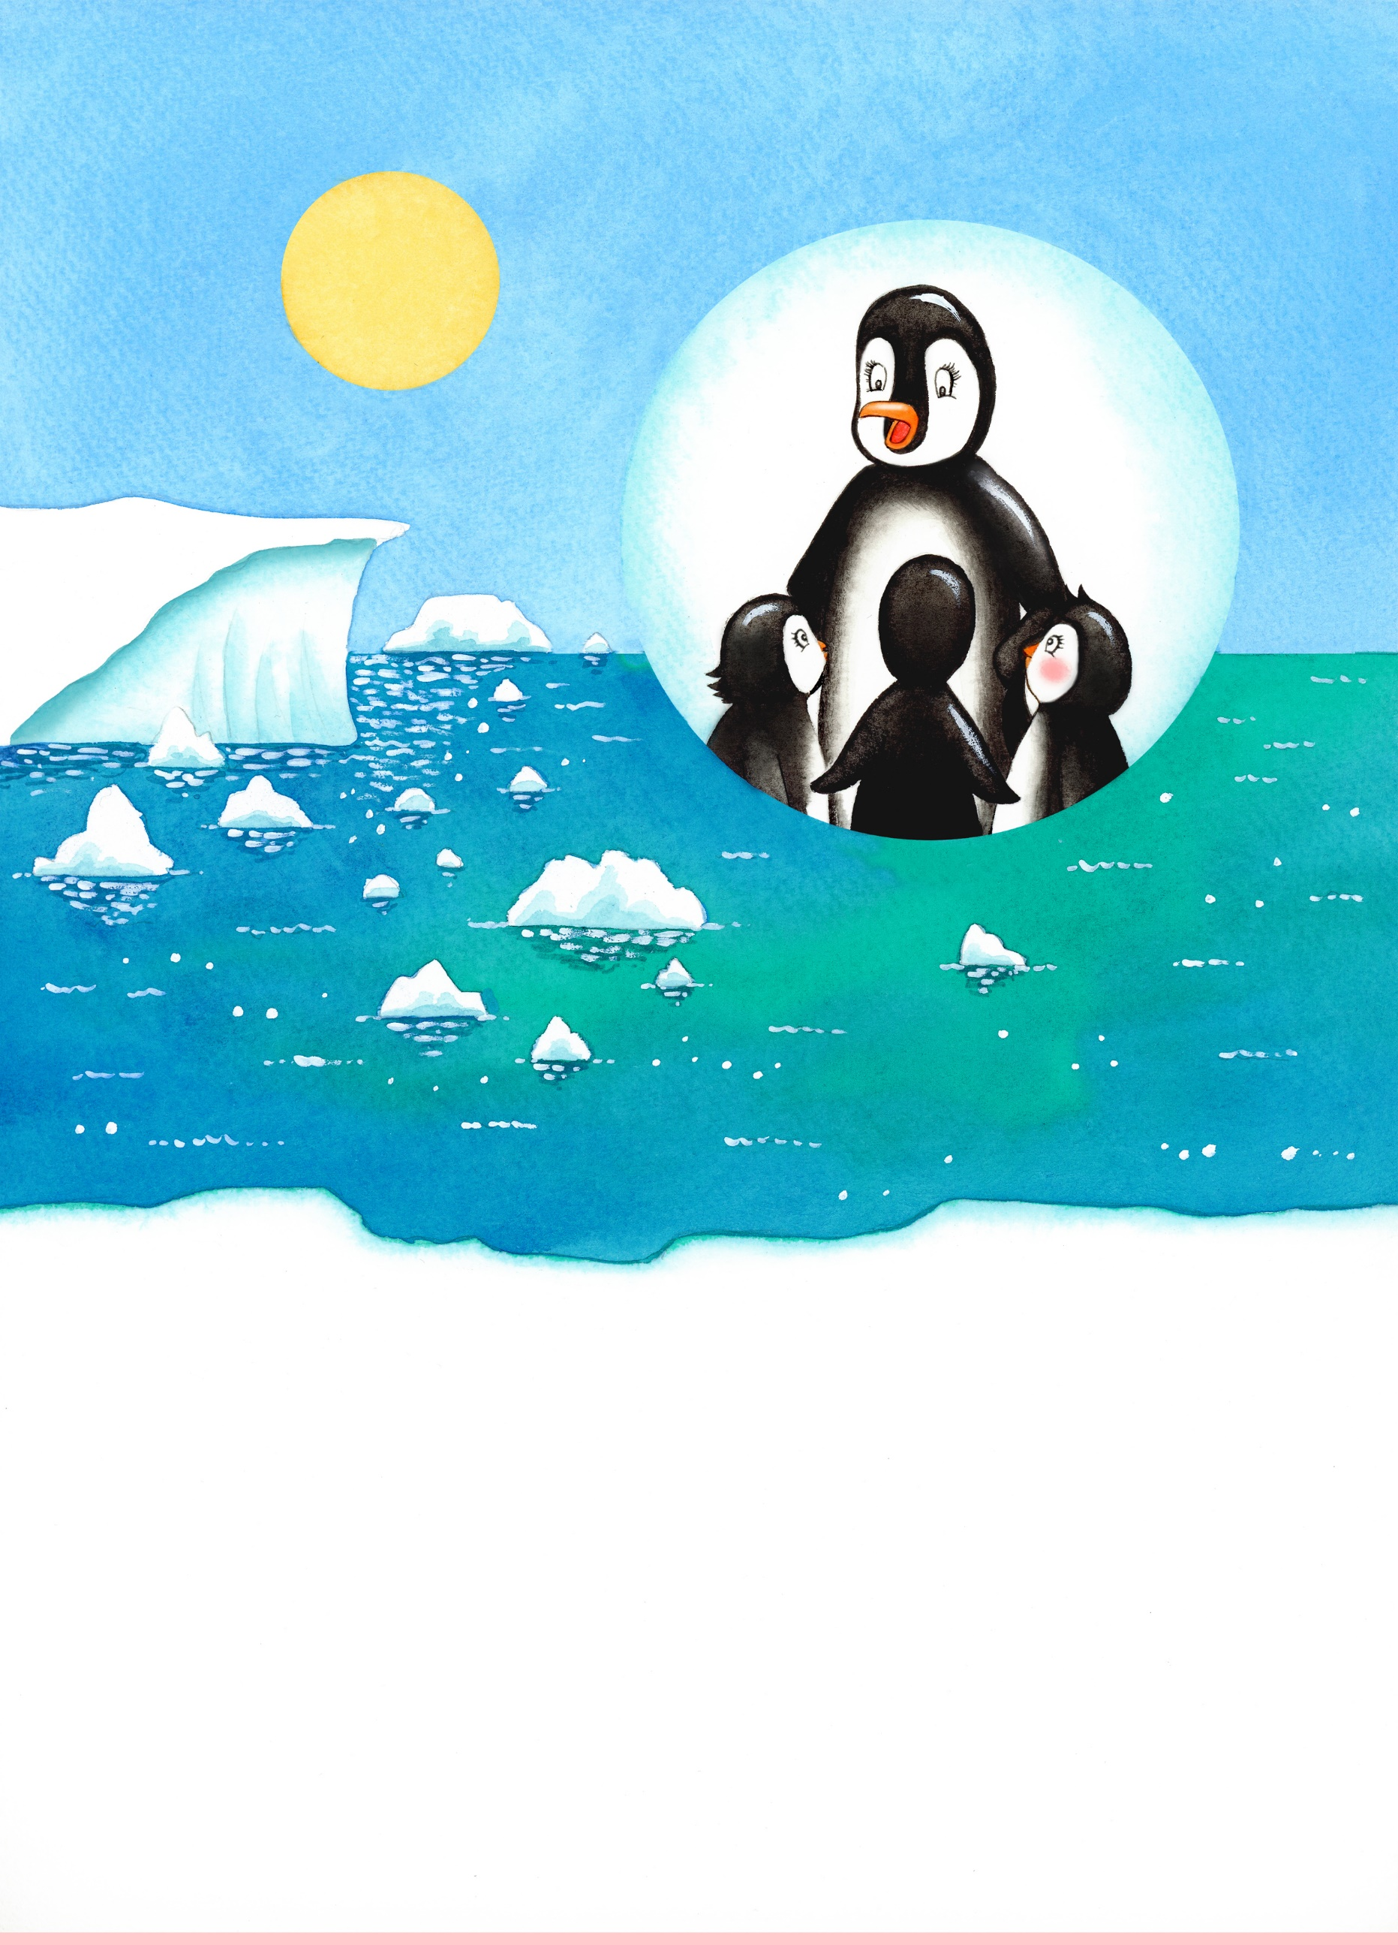

Before they go out, Penny's mum tells them all to be careful. Penny’s mum says the South Pole is getting warmer because of climate change. Little bits of ice at the edge of the polar ice caps have been melting away in the heat.
"Make sure you stay away from the edge of the ice caps when you're sunbathing!" she warns them.

Reading comprehension – Page 3

Try and answer these questions:

What is an ice cap? Can you point to one in the picture?
Do you know what climate change is? If not, can you ask an adult to explain?
Can you find out what causes climate change?
Why is it dangerous for Penny and her friends if bits of ice are melting at the edge of
the ice caps?
Can you think of different ways to stop the ice caps melting?
*

Word matching
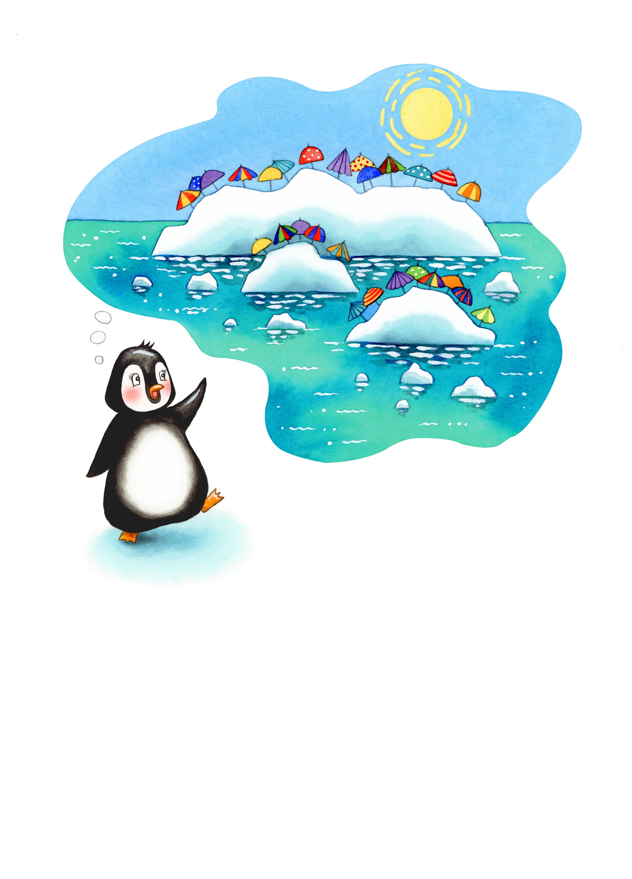
Match the following words with the pictures above:

penguin sun

parasol / sun umbrella ice cap sea

