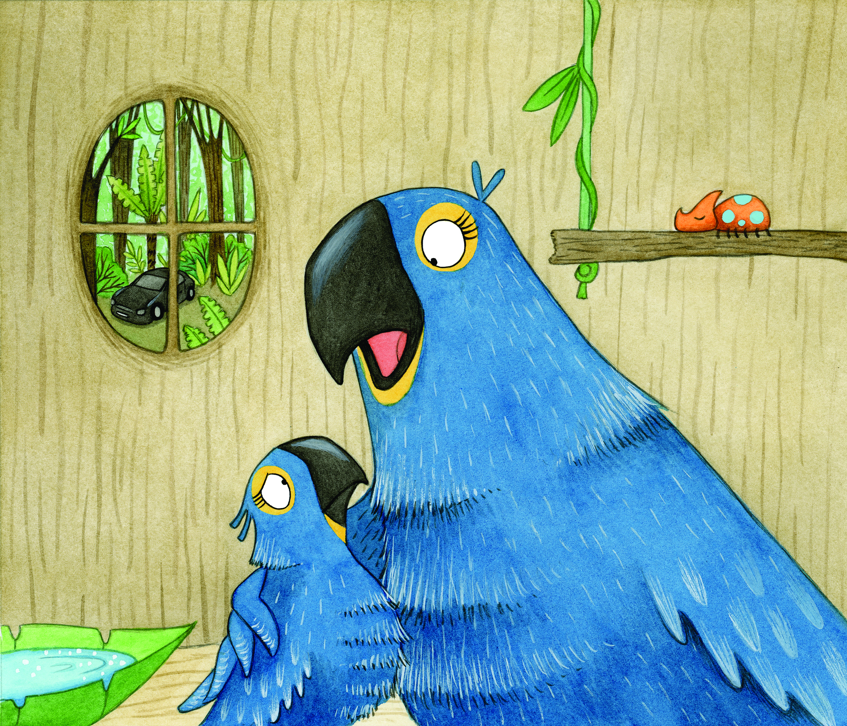
SING-ALONG WITH PAULA
Can you make up a tune to sing these phrases to?

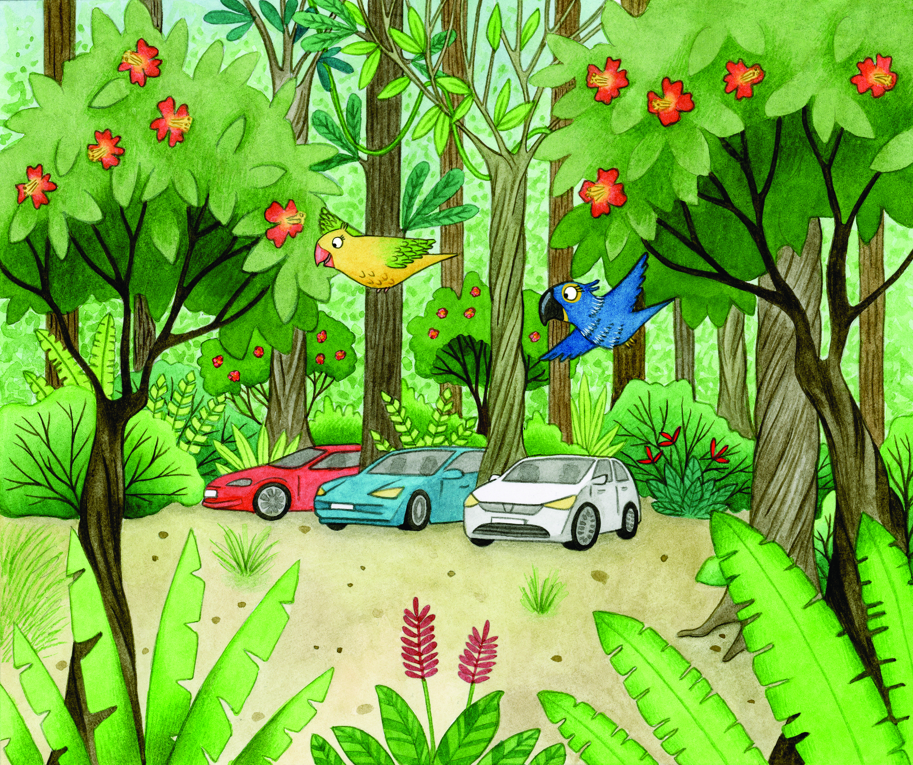

AIR POLLUTION IN THE FOREST, AIR POLLUTION IN THE FOREST
LET’S PREVENT IT NEAR AND FAR
AIR POLLUTION IN THE FOREST, AIR POLLUTION IN THE FOREST
LET’S USE ELECTRIC CARS

