SING-ALONG WITH PAULA
Can you make up a tune to sing these words to?
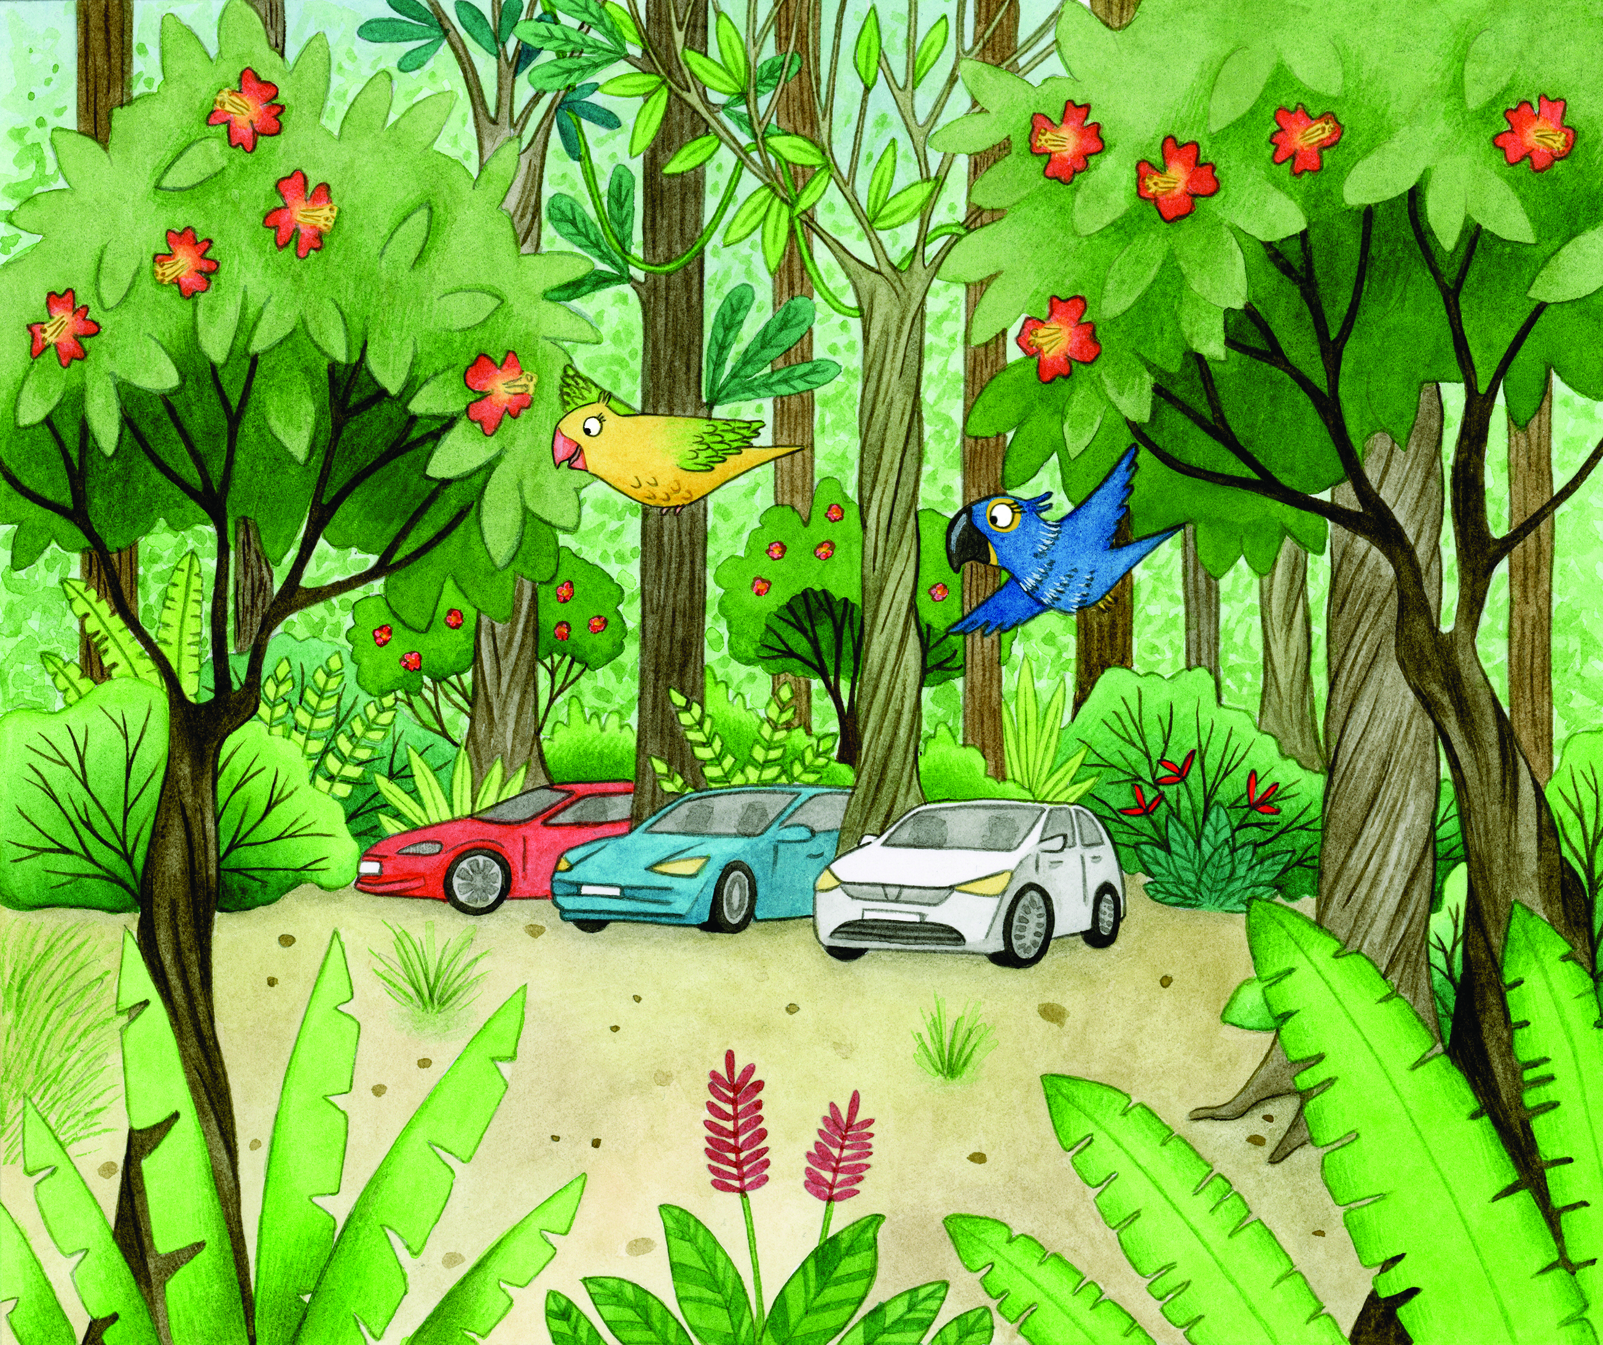

PARROT, PARROT, PARROT, CAR
PARROT, CAR
PARROT, CAR
PARROT, PARROT, PARROT, CAR
PARROT, FOREST, CAR

