GAP FILL– Page 6
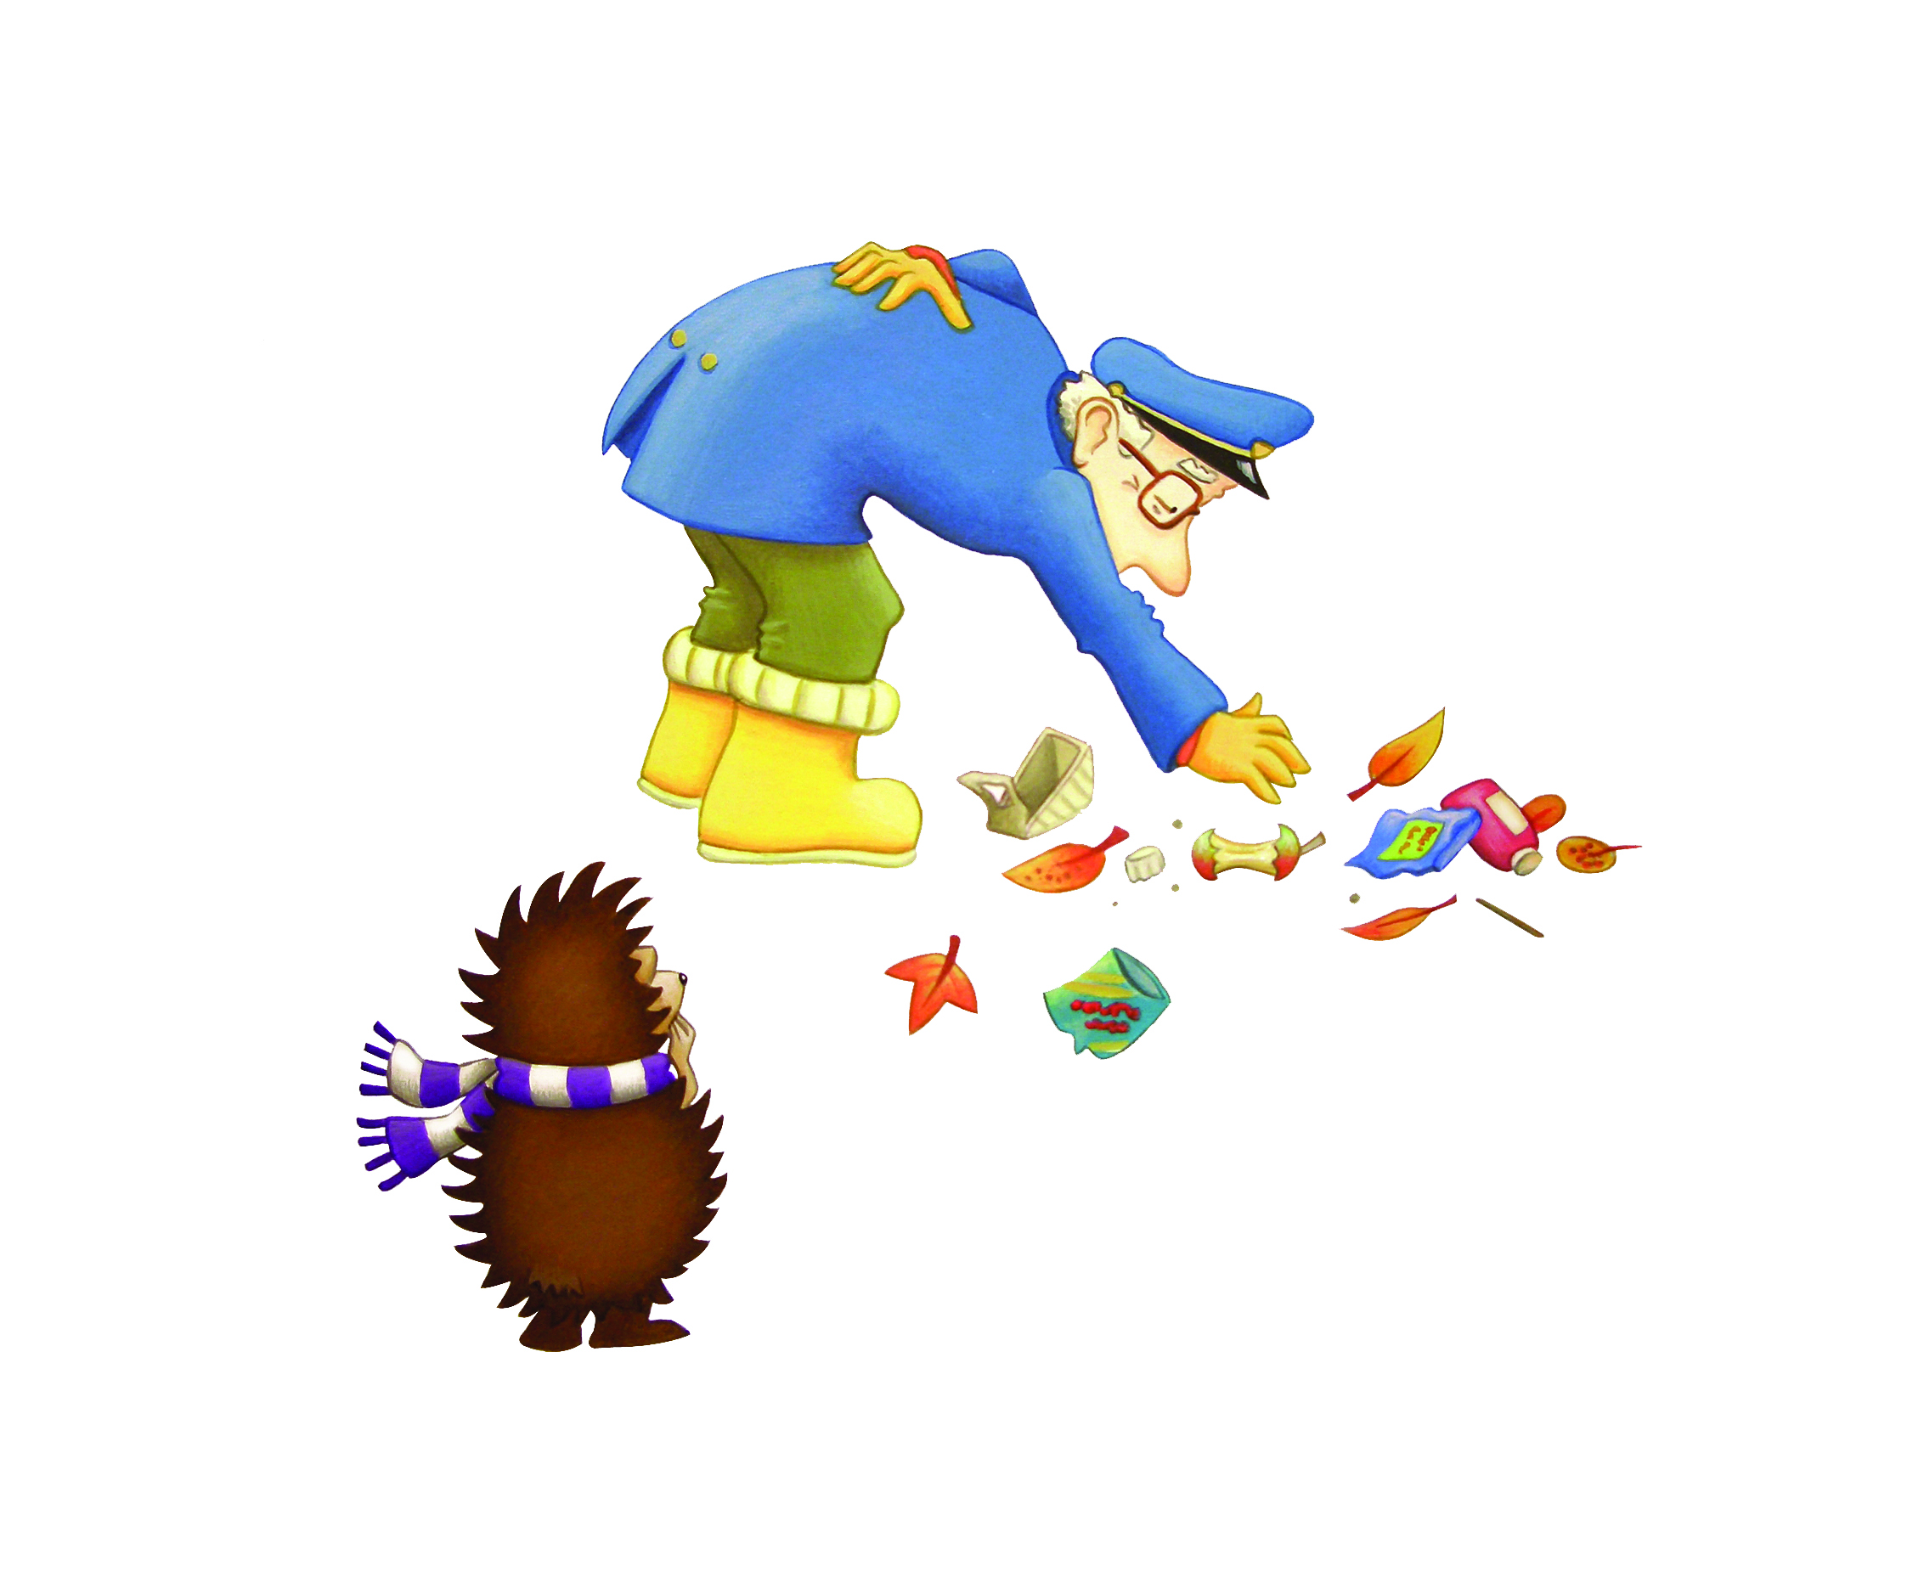
___ Harris has been looking after the park for a very long time. He is now quite ___. Hector can see that he finds it difficult to bend over and pick up the _____ and _______.
Choose the right words to fill in the gaps above.
Mrs. Mr. Miss. Dr.
old happy young sad
leaves plants litter trees
Vocabulary building – What objects does litter include?

READING COMPREHENSION – Page 7
Hector and Harry like the park keeper as he always lets them roll down their favourite hill. He even laughs sometimes when they get to the bottom.
Hector, who likes helping people, decides they need to help Mr. Harris. But how?
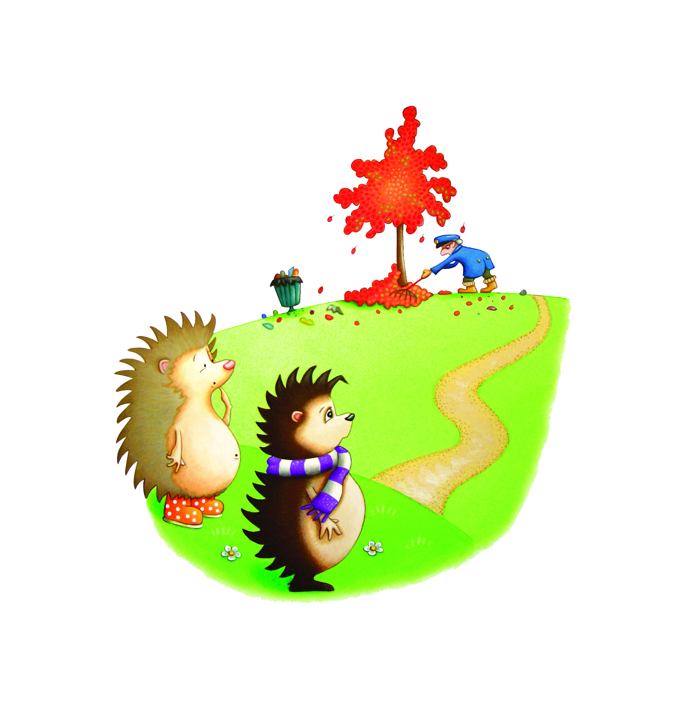
After reading this page in the story, can you try and answer these questions?

- Why did Hector want to help Mr. Harris?

- How did Hector and Harry decide to help Mr. Harris?

- Why is it nice to help people? How does it make you feel?
DRAWING PAGE
Can you draw your favourite picture from
Hector Helps Clean Up The Park?

WRITING PAGE
Can you write about your favourite part of
Hector Helps Clean Up The Park?

