SING-ALONG WITH TYLER
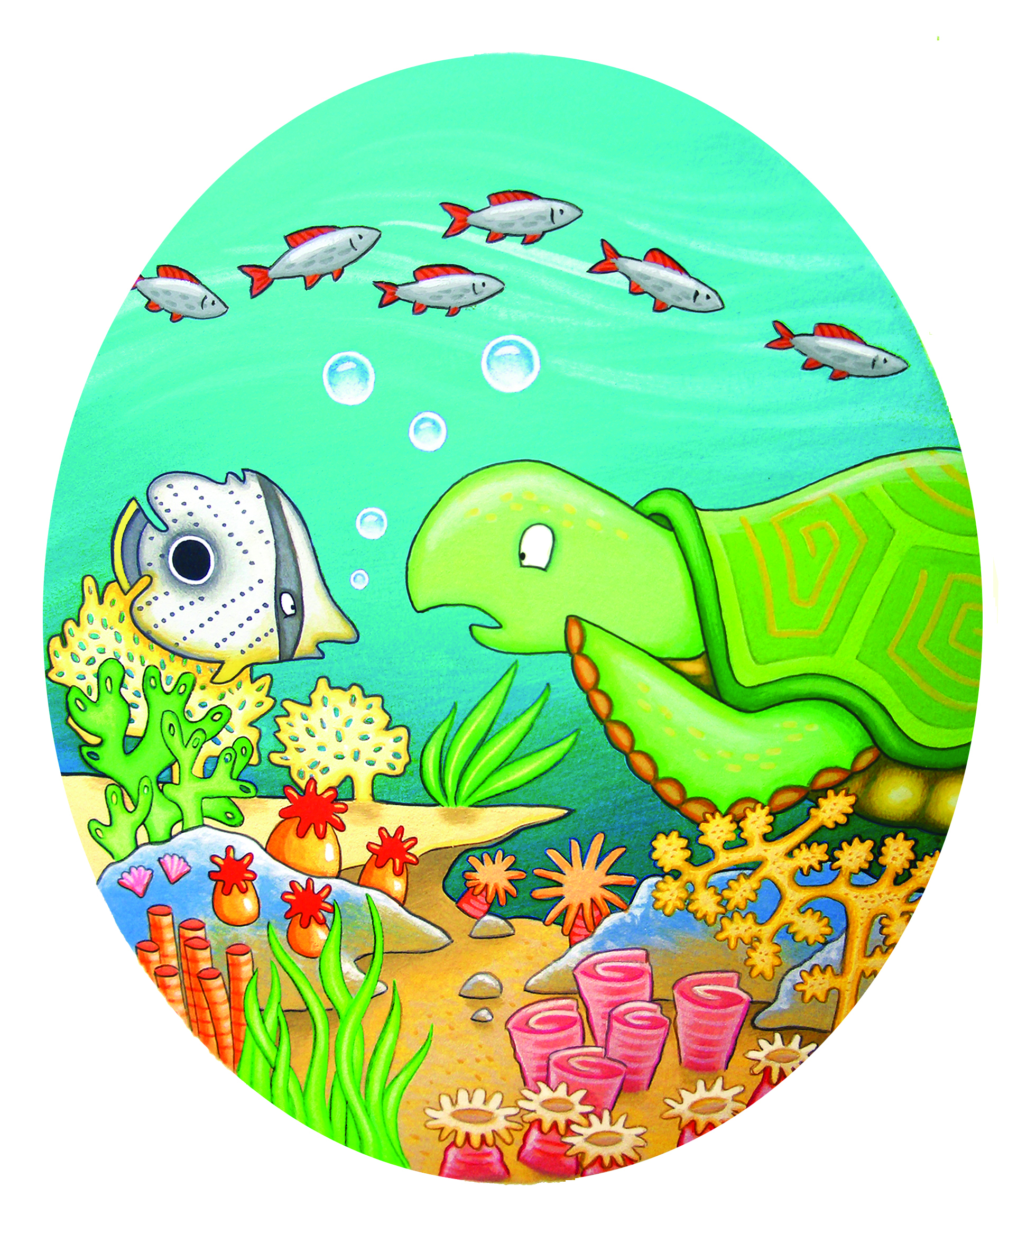
PRETTY CORAL REEF, PRETTY CORAL REEF
PROTECTING IT IS OUR WISH
PRETTY CORAL REEF, PRETTY CORAL REEF
LET’S NOT OVERFISH

