SING-ALONG WITH TYLER
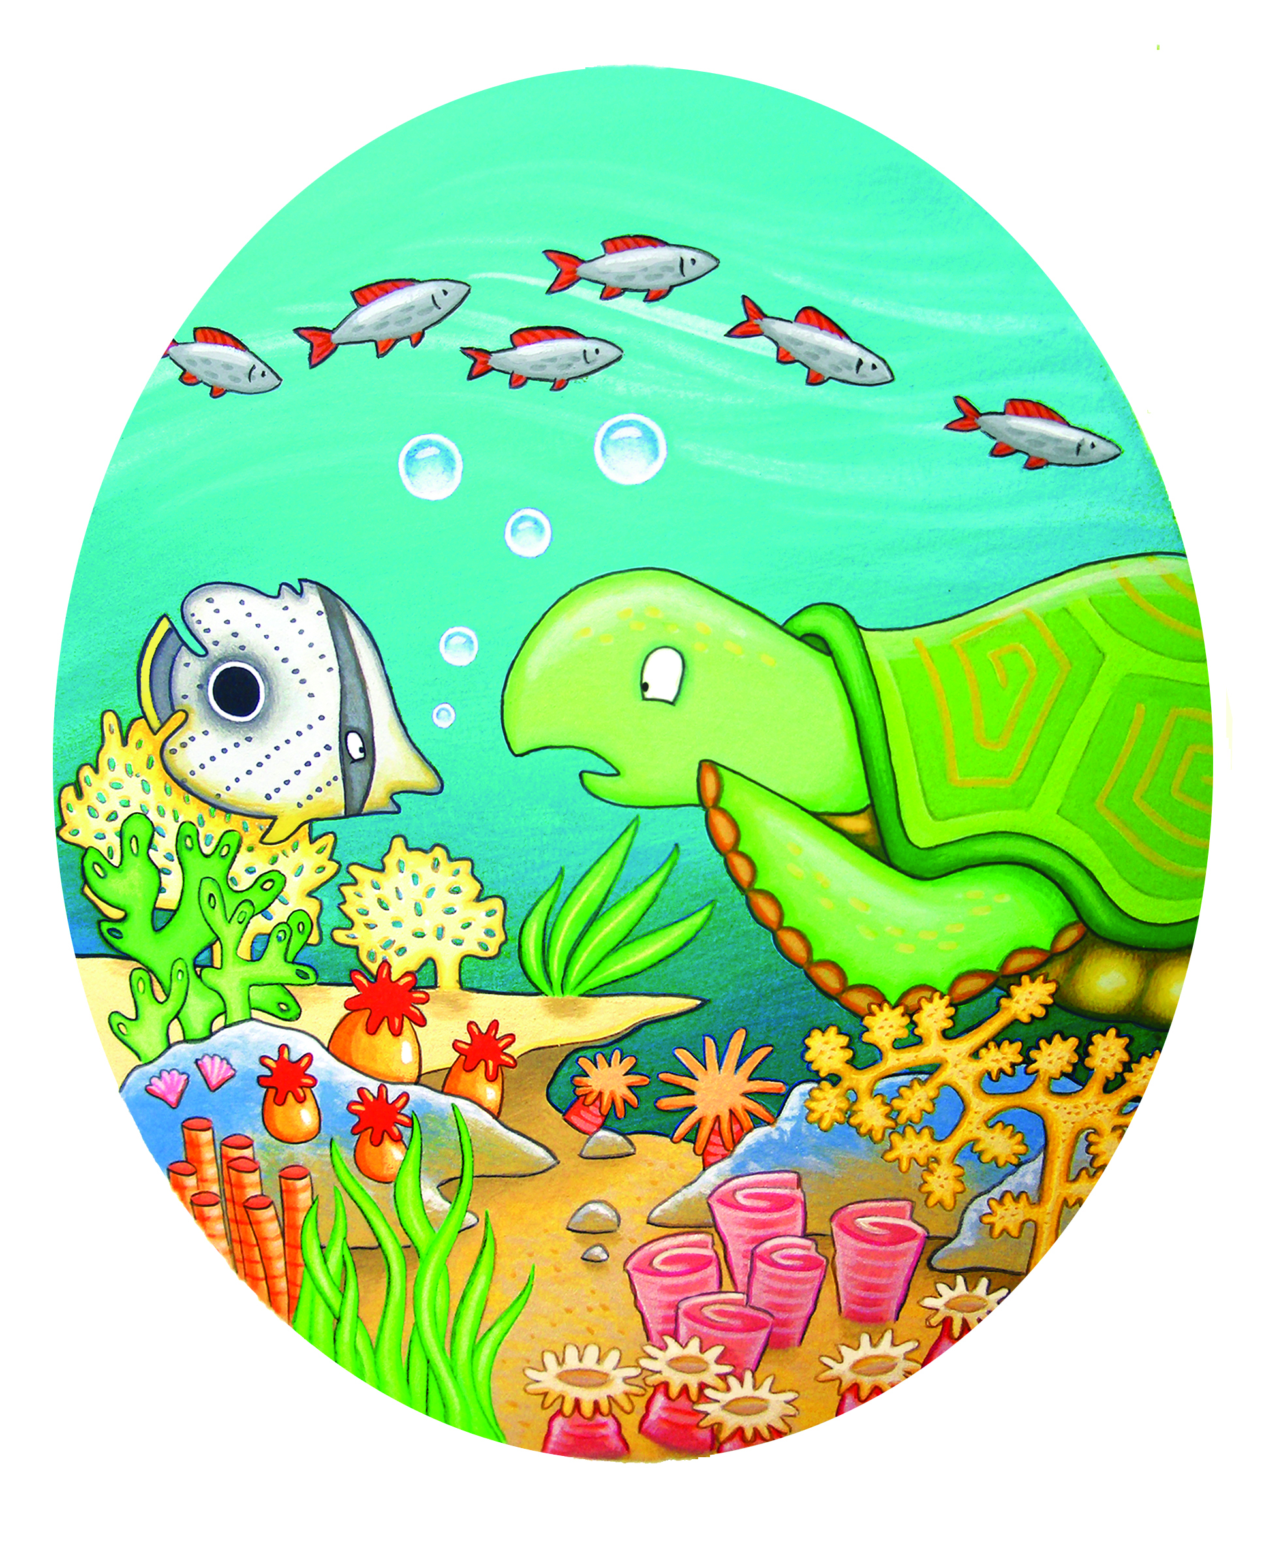

TURTLE, TURTLE, TURTLE, FISH
TURTLE, FISH
TURTLE, FISH
TURTLE, TURTLE, TURTLE, FISH
TURTLE, CORAL, FISH

