SING-ALONG WITH HECTOR
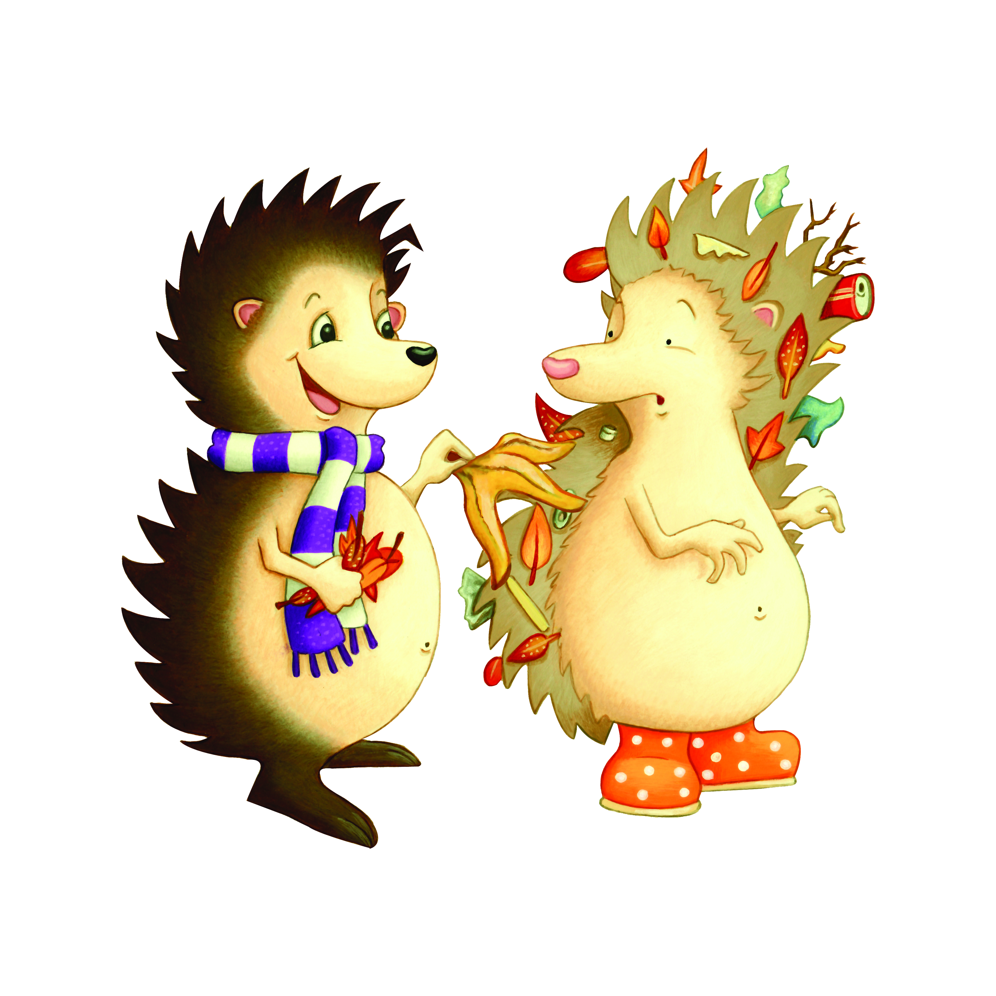

LITTER IN THE PARK, LITTER IN THE PARK,
WE NEED TO KEEP IT CLEAN
LITTER IN THE PARK, LITTER IN THE PARK,
LET’S PUT IT IN THE BIN

